

School of Computing, Electronics and Mathematics

PRCO304

Final Stage Computing Project

2016/2017

BSc (Hons) Computer Science

Matthew Plummer

10450559

Sentiment analysis on social networks

Supervisor: Giovanni Masala

Second marker: Marco Palomino

# Acknowledgements

I offer thanks to my project supervisor for the support provided in the creation and organisation of my final project.

I would like to express my gratitude to the teaching staff and all of the department faculty members at Plymouth University for being there to lend a helping hand and answer any queries. A special thanks to Marco Palomino for helping me greatly through the coding of my program by providing me with the foundations to build upon and for always being contactable for issues and questions.

Thanks to my parents and family for caring for me and helping me to reach my ambitions in life and supporting me no matter what through my education. They were always there to provide unceasing encouragement, support and attention.

I take this opportunity to express my sincere thanks to my university housemates (Paddy, Tom and Kaitlyn) for being with me through my university education. I am thankful and extremely grateful for their support during all my times of study, be it exams or coursework assignments and providing the encouragement to preserver and strive for my best.

# Abstract

This report describes the software development project to carry out sentiment analysis on the social networking platform, Twitter, in order to give a representation of the publics opinion towards specified topic areas via social networks.

The report commences with an introduction to the specified project subject matter followed by an investigation of analysis via social networks. The reasoning, benefits and disadvantages/ problems in using social network to carry out sentiment analysis is outlined and discussed. Following this, a high-level overview of the system, requirements and expected outcomes of this project are highlighted with the aid of visual tools with regards to the architecture of the system.

The development of this software solution and data analytics was carried out in increments over a period of time. Continuous research was carried out before and during the development process. Communication with other data analysts and software developers was carried out throughout this project. This report will discuss the technologies used in reaching the desired outcome of this project, some being; Java, Mongo DB, Twitter4J, Twitter’s API system and Knowi. The developmental approach taken, agile workflow with Git managed code, and the benefits of this approach are also explained in this report.

A description of the testing processes and approaches towards the system and the final deliverable is included. An evaluation of the system in comparison to other similar systems already developed and accessible is carried out and outlined towards the end of the report. The beginning agreed requirements are reiterated and evaluated against the finished product.

A final post-mortem is then presented, which reiterates the various approaches taken within this project and indicates that they were indeed appropriate. Except for the limitations enforced by Twitter with regards to their API service and rate limits and how this was handled within the project and code base.

Details of interim project deliverables are presented in various appendices.

# Table of contents

Acknowledgements 2

Abstract 3

Table of contents 4

Chapter 1: Introduction 6

Chapter 2: Background, advantages and disadvantages of sentiment analysis 9

Chapter 3: Objectives and deliverables 14

Chapter 4: Project management 15

Chapter 5: Legal, social, ethical and professional issues 16

Chapter 6: Overview of technologies implemented 17

6.1 Cloud computing and cloud storage 17

6.2 NoSQL data management systems 18

6.3 Twitter API and Twitter4J 20

Chapter 7: Data analytics tool 21

Chapter 8: Project architecture 24

Chapter 9: Using Twitter API system 27

Chapter 10: Twitter4J code 27

10.1 Filtering requests 28

10.2 Making requests (stream) 29

10.3 Making requests (search) 30

10.4 Making requests (both) 31

Chapter 11: MongoDB code 32

11.1 Connecting to MongoDB Atlas via Java code 32

11.2 Inserting into MongoDB Collection on Atlas via Java code 34

Chapter 12: Analysing tweets for sentiment 36

Chapter 13: Security 38

Chapter 14: Testing 39

Chapter 15: Post-mortem 41

Chapter 16: Conclusions 43

Statement of word count: 10,964 43

Works Cited 44

Appendices 47

User guide 47

Software needed 47

Java IDE 47

MongoDB Atlas 47

MongoDB Shell 47

Creating a database 48

MongoDB Compass 48

Twitter API 48

Java properties 48

Running the code 49

Highlights 50

Highlight 1 50

Highlight 2 51

Highlight 3 53

Highlight 4 54

Highlight 5 56

Highlight 6 57

Highlight 7 59

Highlight 8 61

Highlight 9 65

PID 67

Appendix A (architecture diagrams) 76

Appendix B (User interface) 77

Appendix C (MongoDB Compass) 79

Appendix D (Knowi) 80

D1. Trump data 80

Appendix E (Code snippets) 83

E1. Filtering requests 83

E2. Making requests (stream) 83

E3. Making requests (search) 86

Appendix F (Twitter’s API service status) 87

F1: Twitter API service status for debugging 87

Appendix G (Data comparison) 88

G1. 2017 U.K. General election project data versus Google Trends data. 88

# Chapter 1: Introduction

The objective of this project was to be able to analysis Twitter data based on a topic area in order to drive and support business decisions being made in relation to the publics’ opinion. The final outcome will be the production of graphical representations of the publics outlook on specified areas. This can come in the form of graphs, charts and/ or figures pertaining to the data received and the sentimental analysis carried out on the data.

The users of this project are endless; however, the main focus, and therefore target sector, is businesses which deal with the public on a daily basis and are in the public eye. In targeting these such businesses, the information gained from social media and what the social media users are saying in regards to their company/ product can be very beneficially. The aim to be able to produce an overview in relation to emotions portrayed by the public in order to drive business decisions.

This report will cover a wide range of content, technologies and processes. The main focus of this report is to give an in-depth insight and explanation to the project and how the objectives and desired outcomes were achieved. This project was based around the fact that the volume of data produced via social media by its users is growing at a phenomenal rate with a report from (PaCroffre, 2012) predicting that by the year 2020 data volumes on social media platforms will increase by a staggering factor of 44. It is estimated by (Internet Live Stats, 2017) that over 500 million tweets on average are sent per day, this is a lot of data being produced. This report and project will only focus on Twitter; however, this may not end here. Statistics of other social media platforms (including Twitter) data production per minute can be seen below in figure 1 of this infographic produced by (George, 2015).

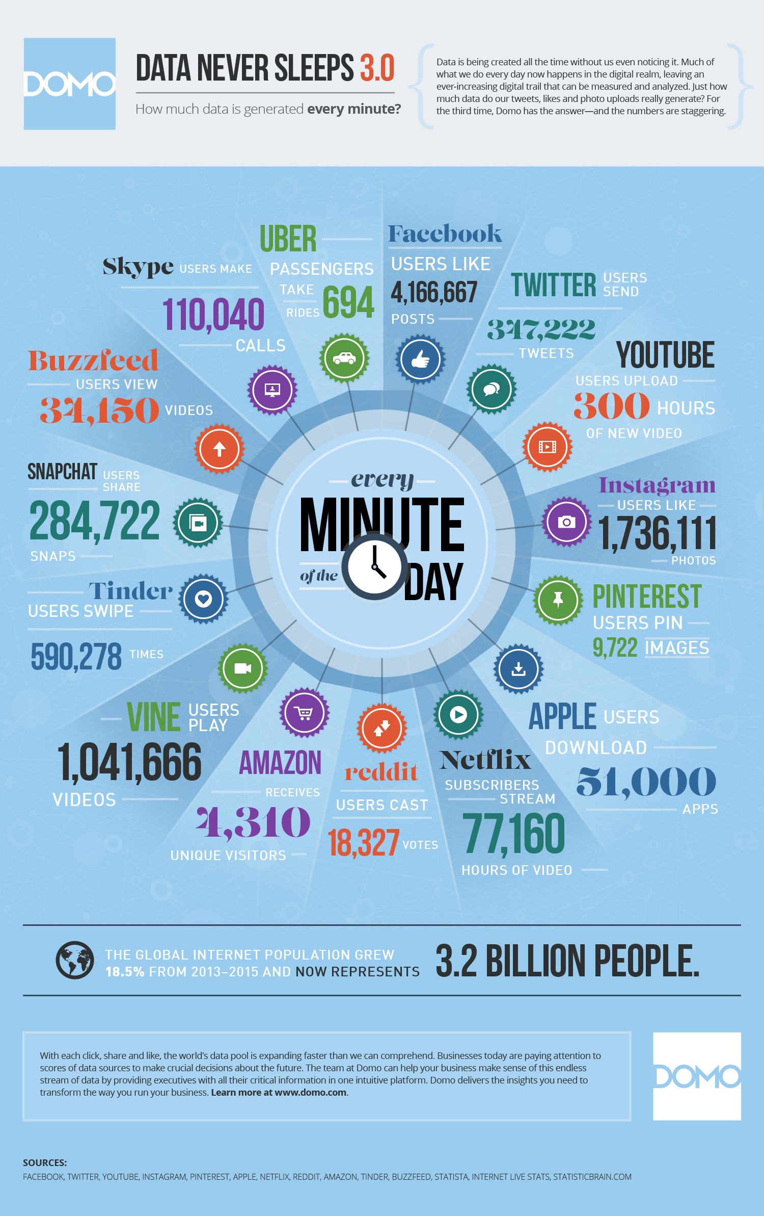

*figure 1* (George, 2015) *showing the average usage of social media every minute.*

All of this data on social media can be used and leveraged to gain information about the population of people whom use said social media platform. In using this data, on Twitter for this project, the publics opinions on certain topic areas can be deduced. As of yet this is not an exact science due to human concepts such as sarcasm, irony and rhetorical statements, however, in saying this the results of sentiment analysis via Twitter can produce an accurate representation of the publics outlook as a whole on a focused area. In extracting and analysing this data, useful information can be extrapolated in order to drive important decisions in business including, but not limited to, public relations, marketing, product placement and more.

This report will be looking into the process of carrying out sentiment analysis on Twitter using the publics tweets. The technologies used will be discussed in detail, the research carried out in order to decide upon these technologies and also how they were implemented to reach a set of graphical representations of the emotional states of the publics social media interactions. All of the data retrieved from Twitter, as well as the sentiment data, is stored on the cloud storage platform; Mongo Db Atlas. A NoSQL database collection storing over 6,000 sentiment words are be compared to the tweets. How this analysis of the tweets, in relation to the sentiment, was carried out is discussed in detail in the main body of the report as well as the retrieval process of the tweets using Twitter4J and Twitters’ API.

Details regarding NoSQL and the integration of this technology will be discussed as this plays a huge part in this project. The process of comparing different approaches and data solutions will be examined, and the reasoning behind deciding upon a NoSQL cloud storage option supported.

It was decided in architecting and production of this application that the search topic areas should be left open ended. In deciding for an open-ended application this means that the process of searching for and retrieving tweets from Twitter can be altered, in the sense that, the search criteria can be easily changed. Upon running the application, the user can specify a word, phrase or hashtag (#) in order to retrieve only the information, they require in which most value can be extracted. In doing so, noise in the data sets can be reduced including ‘garbage data’ which would otherwise occupy space and costing money. Other parameters which can be altered by the user are discussed in the report.

# Chapter 2: Background, advantages and disadvantages of sentiment analysis

Sentiment analysis is not a new concept by any means, however, it is not used to its full potential within the industry. There currently is an interesting system being developed by Brandwatch called Brandwatch Analytics and they state that;

*“Sentiment analysis – otherwise known as opinion mining – is a much bandied about but often misunderstood term. In essence, it is the process of determining the emotional tone behind a series of words, used to gain an understanding of the attitudes, opinions and emotions expressed within an online mention.”*

(Bannister, 2016)

Sentiment analysis is extremely useful, especially in relation to social media monitoring, only relating to the wider publics opinion. This is due to the fact that (Bannister, 2016) social media shifts have been shown to correlate with shifts in the stock market. An example of this is the Obama Administration, sentiment analysis of Twitter conducted during Obama’s campaign for his first election into Office. In carrying out this study it was found that (Balasubramanyan, et al., 2010) over the 2008 to 2009 period, there was a correlation to sentiment word frequencies in contemporaneous Twitter messages. While the results vary across datasets, in several cases the correlations are as high as 80%, and capture important large-scale trends. The results highlight the potential of text streams as a substitute and supplement for traditional polling.

When text analysis was carried out on Twitter for key words and then analysed for sentiment words it was found that the popular opinion did in fact correlate with the election results. The analysis of a number of selected key words can be found below in figure 2 which shows the frequency of these words in Twitter messages. These messages are then used for sentiment analysis later in the project as seen in figure 3, specifically for the key word ‘job’ and how it related to Barrack Obama.

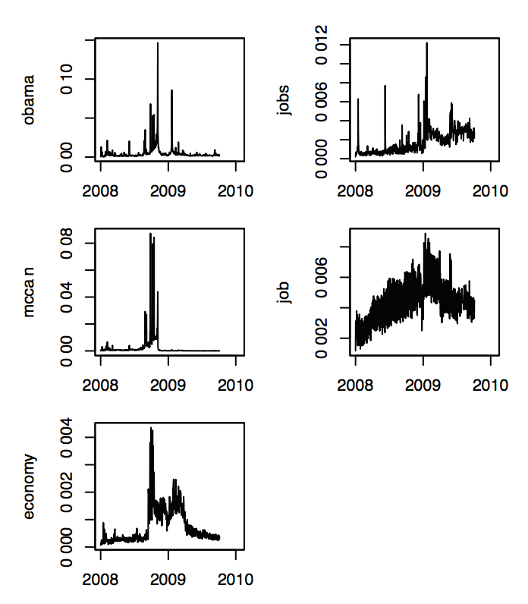

*figure 2: Fraction of Twitter messages containing various topic keywords, per day* (Balasubramanyan, et al., 2010)

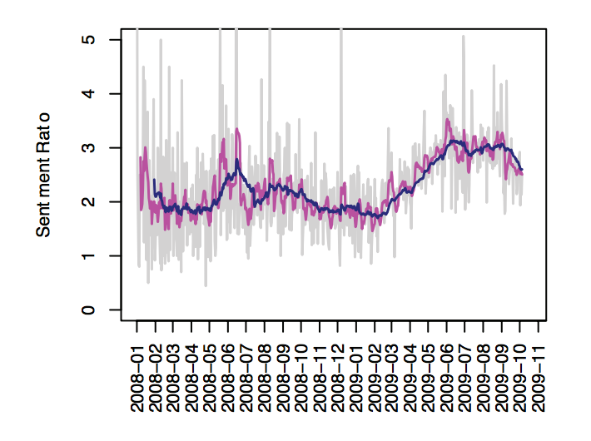

*figure 3: Moving average MAt of sentiment ratio for jobs, under different windows k ∈ {1, 7, 30}: no smoothing (grey), past week (magenta), and past month (blue). The unsmoothed version spikes as high as 10, omitted for space.* (Balasubramanyan, et al., 2010)

This one example of the 2008 presidential election in the United States of America by the Obama Administration shows the benefits of sentiment analysis in social media.

Sentiment analysis of people using social media is a very prosperous area of study, however there are issues that arise with this study, these issues coming from people and human nature/ language. Essentially the process of sentiment analysis effectively comes down to human opinions. The public as a whole can be very opinionated especially in online mediums such as social media platforms, including Twitter. In stating this, opinions are subjective from person to person. There are obvious sentiments such as a complete hatred or love towards a certain topic or product. In trying to place these sentiments on a spectrum of polarity of positive and negative, the extremes of the spectrum, mentioned above, can be easily categorised, however, everything in between can become subjective to the person.

One way to counteract this is taking large data samples. This works due to the face that in this project a conclusion is not trying to be brought about the sentiment of individuals towards topic areas, but rather as a population as a whole. Therefore, the fact that an individual may have been influenced by their day or an argument, for example, will not out way the overall consensus of the entire sample population.

The human natural language can be confusing at times. Human expressions in text, such as irony and sarcasm, can be difficult to detect in sentiment analysing software. In order to do this some form of machine learning needs to be implemented as context of the text is a factor in detecting these. In order to be able to pick up on these tropes some form of understanding of what the text is trying to express is needed. As stated by Russell Matthews, co-founder and Principal of Zaffra, supports this point that has been expressed here by declaring a very impacting statement that (Guess, 2011) analysing natural language is the problem of the next 2-3 decades. It’s an incredibly difficult issue types of ironic language are problematic to detect for computer software and machines when the text in question is looked at in isolation. It’s imperative to have a sufficiently sophisticated and rigorous enough approach that relevant context can be taken into account. Although this project is not at this level of precision to be able to take into account context, due to the fact that this is a much larger and wider issue in the field of sentiment analysis, an accurate representation of the publics opinion can be depicted.

Social media is an ever-growing popular platform used around the world and it is showing no signs of slowing. Year on year the number of users on all social media platforms is on a steady upwards trend and is predicted to continue this way in the coming years. In a study carried out by (Statista, 2017) the upwards trend of social media users from 2010 and projected user numbers up to the year 2020, can be seen in figure 4 below shown in billions. This is followed by figure 5 showing an analysis of monthly Twitter users quarterly from the first quarter of 2010 to the final quarter of 2016 in millions which also shows a steady upwards trend.

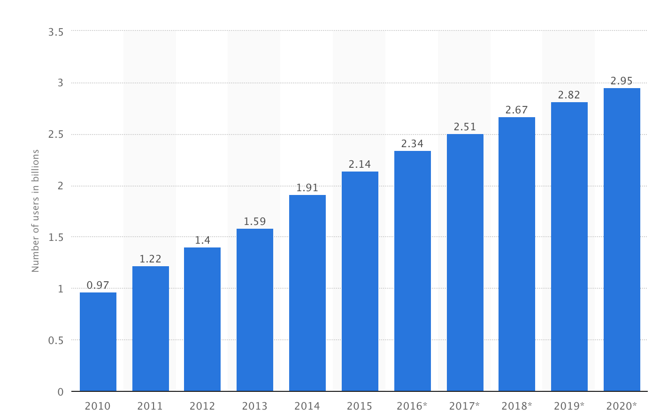

*figure 4: the year on year number of social media users represented in billions.* (Statista, 2017)

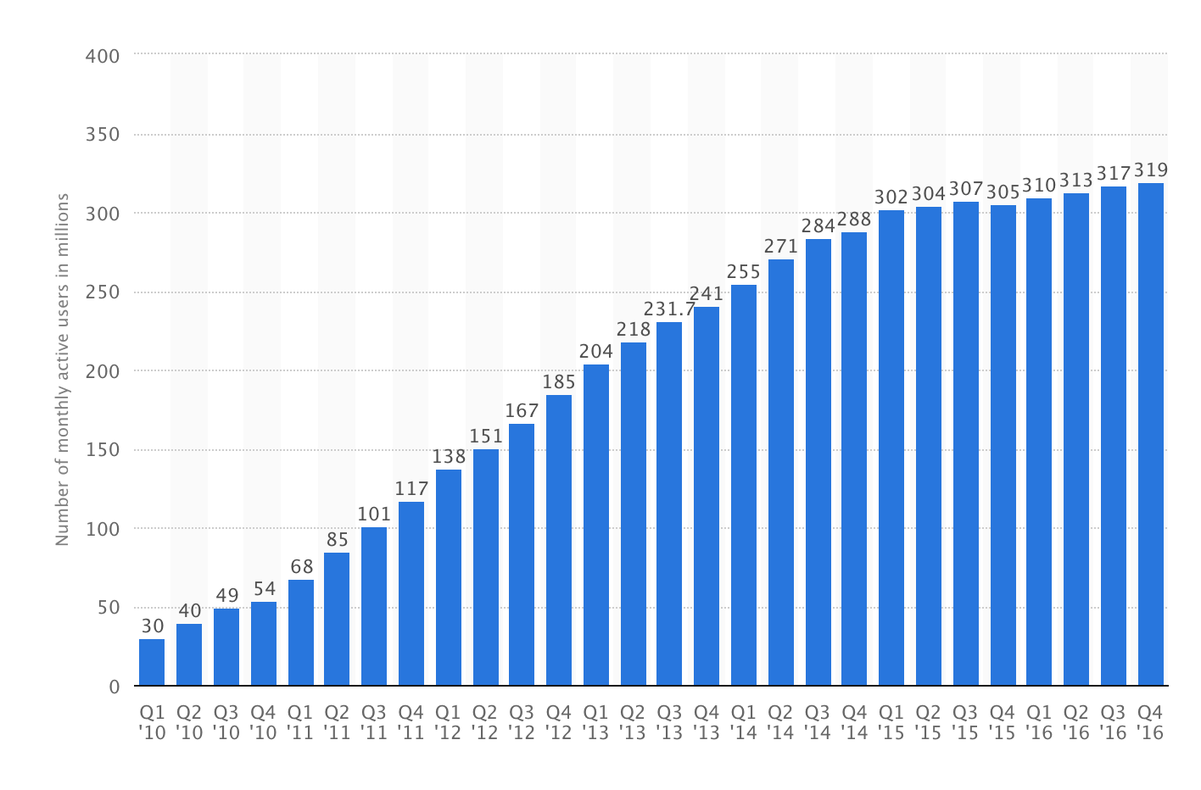

*figure 5: quarterly Twitter users in millions from 1st quarter of 2010 to 4th quarter of 2016.* (Statista, 2017)

Quarter on quarter and year on year the population size on social media increases. All of which are contributing to the vast volumes of data in the form of opinions, comments, points and concerns which can all be used to extract useful information. The possibilities for this medium are endless and waiting to be accessed and used.

# Chapter 3: Objectives and deliverables

The core objectives of this project are stated above, which to reiterate is to be able to exhibit the effectiveness of sentiment analysis on social media platform(s) (Twitter) in a high-level overview resulting in an understanding of the publics opinion on a certain topic area, area of discussion or product and/ or company. In stating this, this application of sentiment analysis is not the only possibility. This type of sentiment analysis can be used on any subject matter that is conversed on social media as evident by the political application of sentiment analysis in relation to the United States presidential election summarised above.

As core functionality, the project should be able to:

* Extract tweets from Twitter based on text/ hashtag(s).
* Use sentiment analysis to determine the user’s emotion portrayed in the tweet.
* Determine the overall emotion felt towards topic areas.
* Retrieve a live stream of tweets from Twitter and carry out real-time (or as close to as possible) sentiment analysis.
* To be able to carry out a search of Twitter for a sample number of tweets on a specified day (within the allowance of Twitter’s API system.)

The aims, objectives and deliverables for this project are stated below as follows:

* To deliver a set of facts and figures based on information extracted from analysing Twitter tweets with regards to the sentiment expressed.
* A series of graphs and charts to fit each individual’s needs are to be produced, this is to offer a visual representation of the information produced.
* To deliver the ability for the user to trend the sentiment present in tweets over time to determine how public opinion changes.
* The topic and search phrase should changeable with ease in order to accommodate different search criteria for tweets.

# Chapter 4: Project management

This project was developed using Java with regards to the Twitter API in order to retrieve the data and also to analyse the data. Intellij IDE[1] was used as the development environment to programme the project. MongoDB Atlas[2] was used to store the data retrieved and MongoDB Compass[3] was used for quick data visualisation and editing if needed.

All code was version controlled via GitHub[4] within a repository under a SSH key and all sensitive information (such as login information) was to be omitted in the git ignore file. The Git structure consisted of a Master, a feature and a test branch. Work was done on feature branches and tested on the test branch. Once testing had passed the test branch was merged to the Master branch and the feature branch was deleted. This was to maintain the integrity of the work and to allow back outs and code reverts. This cycle of work was iterated through for each feature implemented and bug fixed.

This project was carried out in an agile workflow model. This was done to allow the flexibility for the goals of the project to move slightly or change without causing too much of an issue. The project was planned out in two week sprints with goals that were developed under the S.M.A.R.T goal model for each sprint. At the end of each sprint, the goals and overall progress was assessed and adjustments made if necessary. A contingency was included to allow for any unforeseen issues or problems which slowed the development process.

At the start of the project, extensive research was carried out on different technologies that would be applicable, thus ensuring the most applicable software was used for each individual task. All areas of the project were researched in this fashion before development was started. A series of diagrams were created to illustrate the expected process of the system to represent the architecture and show how the end task was achieved. Extensive thought was carried out on each aspect of the development of the project with additional thought put into those areas which changed during the development. Diagrams for the inner working of code sets were created to ensure the work done was conforming to best possible coding practice.

# Chapter 5: Legal, social, ethical and professional issues

In conducting this project on social media some legal and ethical issues had to be considered.

Due to the fact that this project accesses information via an internet medium and stores this information for analysis, what was being collected had to be chosen carefully. In using Twitter API, the developer has access to all information which is available in conjunction with the posting of the tweet. This includes the geo location (if the user of the tweet permits the use of this), the users username, usernames of other users if the Twitter user is mentioning others in their tweet and also the text of the tweet. With regards to this project not all of this information was required. The only information extracted from the tweets were the text of the tweet and the date the tweet was posted.

If it was decided that during further development of this project that other information, that was listed above or otherwise, was decided to be extracted this could be done. All information that is available for extraction on each tweet has been done so with the consent of the poster of the tweet as stated in Twitters policies including the terms of agreement and privacy policy that each user agrees to upon the creation of their Twitter account. These policies can be found on the Twitter website[5].

With regards to the legal and ethical requirements in place by the University of Plymouth this project is fully covered. This is due to the fact that data collected is not excessive and for a specific purpose. Personal information is not collected or stored with regards to any member of the public. All data collected has been agreed upon by the user and is within the public domain.

All work used or considered for use as well as research and reading carried out has been referenced with due credit given within this report. References can be found at the end of this report.

All work should be considered the product of the author of this report, unless otherwise stated or referenced.

# Chapter 6: Overview of technologies implemented

There are several technologies implemented in this project; most of which are extremely desired by those in the computing industry and are on the rise in popularity and usability. These technologies are listed below with explanations of what each is and their use.

## 6.1 Cloud computing and cloud storage

Although cloud storage and cloud computing may be seen to be interchangeable phrases when talking about ‘the cloud’ in layman terms this is in fact not the case.

Cloud storage is as its name suggests, this is simply storing documents, data, files etc. on cloud servers. In accordance with (Cloud Carib, 2016) cloud storage entails the uploading of data through the Internet to cloud-based servers which can then be accessed from multiple devices using the Internet as a medium. Cloud storage is used by businesses to allow data to be accessed by any allowed user from any location permitted. Cloud storage platforms offer one single location for data analytics tools to connect to in order to carry out analytics and in order to visualise data.

Cloud computing, on the other hand, is used to complete specific digital tasks. In moving the computation to ‘the cloud’ the processing of the operation needed can be spread across multiple processors. Moving computation, most beneficially, expensive/ extensive computation can save time for these tasks and therefore, in relation to data analytics results and information can be produced much more quickly giving a benefit to most companies.

This project heavily implemented both of these concepts of cloud storage and computation. The chosen storage method is the use of MongoDB Atlas, the official definition of which from MongoDB is that:

*“MongoDB Atlas is a cloud service for running, monitoring, and maintaining MongoDB deployments, including the provisioning of dedicated servers for the MongoDB instances.”*

(MongoDB, 2017)

In order to store the vast volumes of data which were retrieved from Twitter a cloud based storage system such as that of MongoDB Atlas was needed. A number of cloud storage options were considered including, but not limited to, AWS (Amazon Web Services) Redshift, and Oracle. Upon considering the options it was decided that the NoSQL approach of MongoDB was of best use which will be highlighted later in this report. As a result, a cluster was started in MongoDB Atlas which is where all the data was stored. With regards to cloud computing, it was also decided to use a MongoDB product called MongoDB Compass which is:

*“MongoDB Compass is designed to allow users to easily analyse and understand the contents of their data collections within MongoDB and perform queries…provides users with a graphical view of their MongoDB schema by randomly sampling a subset of documents from the collection. Sampling documents minimizes performance impact on the database and can produce results quickly.”*

(MongoDB, 2017)

Examples of MongoDB Compass visualisations can be seen under appendix C of this report. This program was used to visualize the data contained within the Atlas cluster. This provided quick feedback with information in relation to the raw data and sentiment analysis which was carried out on the Twitter data. Due to the structure of the Java code, tweets were analysed in real-time resulting in the real-time visualization of this data.

## 6.2 NoSQL data management systems

NoSQL, or Not Only SQL, databases are a different take on the usual Relational Database Management Systems (RDBMS) model. NoSQL contrasts to databases that adhere to SQL's relational methods in the way that Rouse states that (Rouse, 2015) traditional databases data are placed in tables, and the data schemas are carefully designed before the database is built. NoSQL databases especially target large sets of distributed data. Rouse also explains that (Rouse, 2015) NoSQL DBMS’s are designed to manage the scalability and performance issues that relational database management systems (RDBMS’s) were not originally intended to deal with.

In researching both relational and NoSQL database management systems, it was decided that NoSQL would be best suited for this project. Reiterating the points made above, due to the fact that NoSQL databases are best suited for the management of large unrelated data sets, with the ability to scale and maintain the performance of the manipulation and access to the data and the fact that, for this project, there will be no relations between data sets, NoSQL was therefore the approach to be taken forward for this piece of work.

The storage system/ architecture of a typical NoSQL system can be seen below in figure 6, this is the storage model that this project follows with a brief explanation following.

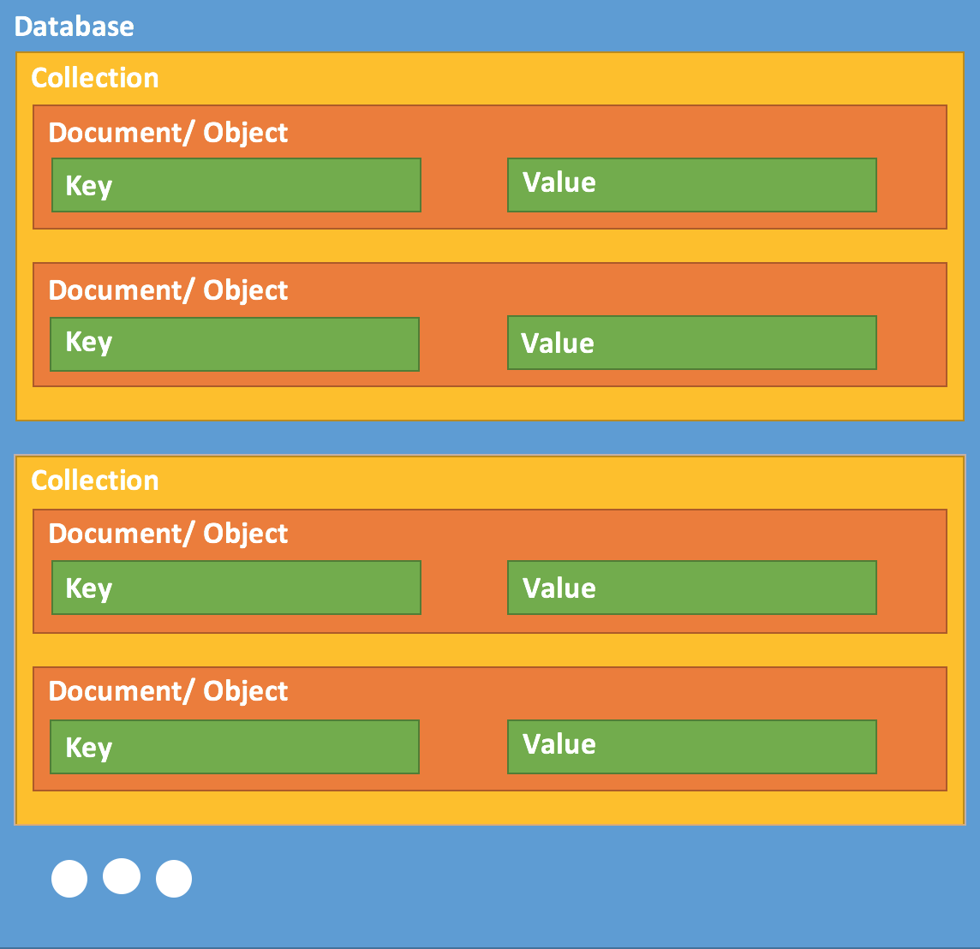

*figure 6 showing a typical NoSQL database structure model.*

**Database**: this is same as a database in relational data models. The database acts as the highest level of storage where all other data and information is stored.

**Collection:** in terms of a relational data model this acts as a ‘table’, here all data is inserted into and stored. Collections are used for sorting similar data into groups for ease of accessing, processing and analysing.

**Document/ object**: an object or, most commonly referred to as, document, acts as a ‘record’. Within a document pairs of corresponding keys and values are stored. Documents are used to organise data into beyond the basic level of key-pair matching. Each document will be assigned a unique object ID which can be used to uniquely identify and retrieve the document.

**Key**: the key is, in a sense, a ‘field name’, the key will give information regarding the stored value. This allows the user, or analytics tool, to relate the value data to a corresponding key in order to understand what the retrieved values represents.

**Value**: this is the data that is ingested into the data storage system. This acts as the raw data and also processed information. The value, along with the matching key, is the core of the data and the structure. The value is a record of data in relational data models.

## 6.3 Twitter API and Twitter4J

API stands for Application Programming Interface, according to (Tech Terms, 2016) an API is a set of commands, functions, protocols, and objects that programmers and/or developers can use to create software or interact with an external system. In the case of this project an API call is used to retrieve data, in the form of Tweets, from Twitter. As a result, an API request is sent to the back-end servers of Twitter (as opposed to the front-end user interface of Twitter) where a response is obtained through what is sent back to the user. Within an API request, the data needed can be specified. This can filter on many fields with date/ time, language, username, tweets containing specified text to name but a few. API’s are used in a wide range of applications in order to achieve quick and accurate responses from an application or service, API’s also allow programmers to reduce the number of lines of code needed to be written by providing a standard set of commands for performing common operations.

Twitter4J is a Java based library for use with the Twitter API. In using Twitter4J access to the Twitter API can be easily integrated into any Java application or IDE. Twitter4J provided a set of predefined code classes which are used to request information from the Twitter servers for specific data. The fact that Twitter4J is an open source and free to use library means it is easily downloaded and installed. The number of developers working on and using this package has been on the rise since its conception. It has grown as a platform over the years adding new functionality which can be used for multiple tasks, some examples of these functionalities are live Twitter tweet streams and Twitter tweet searches in order to retrieve past tweets. Twitter4J can be implemented in a few ways, a Jar file is provided with all needed functionality (which is compatible with Windows or Unix and Java 5 or later) which can be downloaded from their website (Twitter4J, 2017)[6], the library is also available via GitHub or can be integrated into a Java project using Maven. The detailed use of Twitter4J and the Twitter API will be explained later in the report.

# Chapter 7: Data analytics tool

The purpose of this project was to carry out analysis on Twitter tweets which have already been analysed for sentiment previously in the process. In order to carry out this task an analytics tool was needed in this case. Although an analytics tool was used to carry out the analytics, knowledge was needed in order to create graphical representations of the data. This allowed for useful information to be extracted from the presented data. The knowledge required was knowledge of the data and what each field contained. In stating this, the data keys (field names) were created with the consideration of making it self-explanatory. Having this knowledge allows the user to create basic graphs allowing them to visual the data, however, to be able to carry out more detailed ‘powerful’ analytics, knowledge in SQL was needed, the reasoning behind this is below.

The tool used to carry out the analytics was Knowi [7], Knowi is an online analytics tool which allows the user to connect to a variety of data sources. The user can build graphs, charts, tables, diagrams and more which can all be displayed on a dashboard and then shared to other companies and/or clients. Knowi explain what they do as a company as follows:

*“We provide native integrations to a range of unstructured and structured data sources to allow you to query your data powerful ways either in the cloud or on premise. Analytics on NoSQL databases typically require ETL into a relational data stores. Our solution provides completely native integrations to NoSQL sources to enable data discovery and query generation to instantly visualize, analyse and store that data.”*

(Knowi, 2017)

In using this software for graphical visualisation of the data, results in all visualising of the data to be carried out off site from the cluster where the data is stored. There are benefits in allowing Knowi to handle this load, one being that it reduces the stress placed on the Atlas cluster. This reduces the risk of the cluster experiencing downtime as a result of load stresses, which would in turn result in the application being unusable. The cluster is queried only when it is needed in order to retrieve new data which has been recently inserted into the cluster.

The below diagram in figure 7 shows how Knowi goes from connecting to the specified data source to plotting graphs with everything in between:



*figure 7: Knowi process to produce visual representations of data.* (Knowi, 2017)

As can be seen from the above diagram in figure 7 Knowi has a multistep process in order to produce the graphical content used to visualise the data. In terms of this project this was a huge advantage to be able to push the graphical processing of the data off site due to the facts stated previously. Native integration to the data source, in this case NoSQL connecting to the MongoDB Atlas cluster, was an advantage to this project. This allowed for easy connection to the data source and increased performance in retrieving the data to be plotted from the cluster. One topic area used was the 2017 U.K. General election, a graph of which can be seen below with examples of graphs and visualisations created in Knowi found under appendix D at the end of this report.

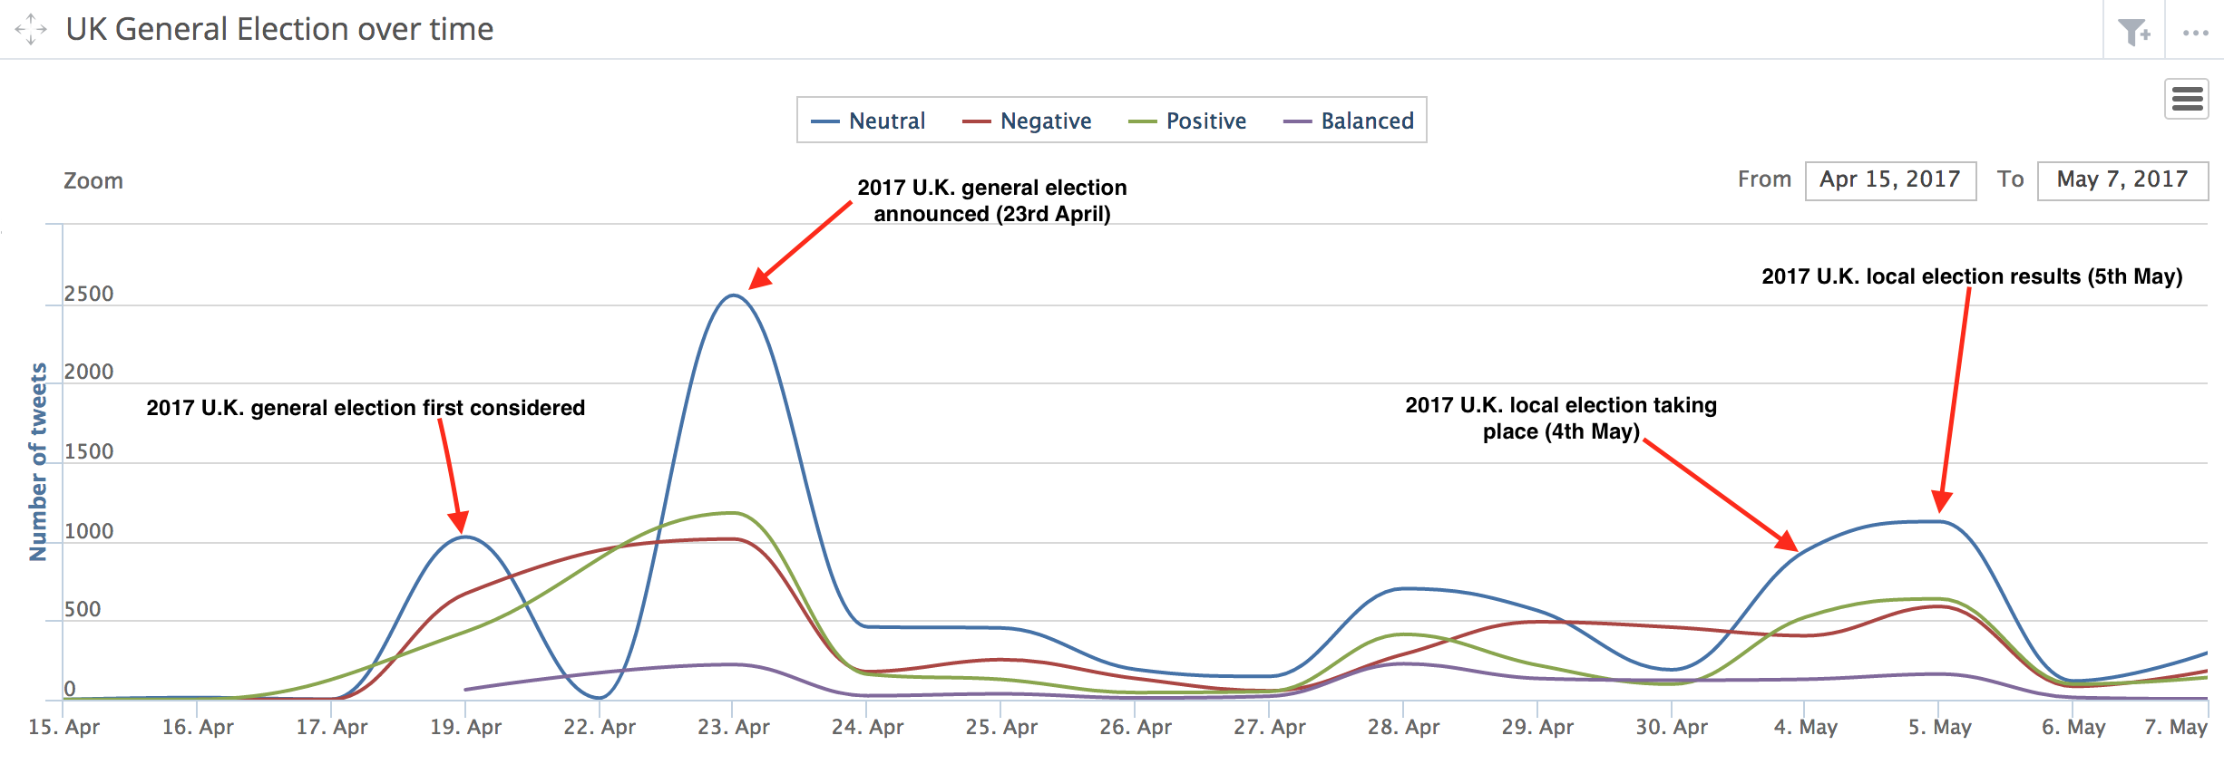

In order to ensure that the results obtained, analysed and plotted were correct. The number of tweets received on a topic area was compared to the global search results of Google using Google Trends[8].

*“Google Trends is an online search tool that allows the user to see how often specific keywords, subjects and phrases have been queried over a specific period of time. Google Trends works by analysing a portion of Google searches to compute how many searches have been done for the terms entered, relative to the total number of searches done on Google over the same time.”*

(Rouse, 2013)

Google Trends therefore allowed the comparison of the dataset, of this project, to a known accurate dataset. Example search topics were selected and used across both, an example being the 2017 U.K. General Election. It was found that the results of Google Trends match closely to those retrieved in this project. This helps to support the work being done in this project allowing it to have some reliable value. The example comparison mentioned can be seen in appendix G of this report.

# Chapter 8: Project architecture

This project was made up of four core components these being:

1. Twitter API
2. Java based programming
3. NoSQL database storage model using MongoDB/ MongoDB Atlas
4. Analysed data visualisation using Knowi with some initial data visualisation using MongoDB Compass.

The architecture went through several iterations as the project came into its own. The first iteration of the project architecture can be seen below in figure 8, a more detailed diagram, which is the final architecture, can be seen in figure 9 followed by an explanation. Intermediate project architecture diagrams can be seen in the appendices of this report under appendix A.

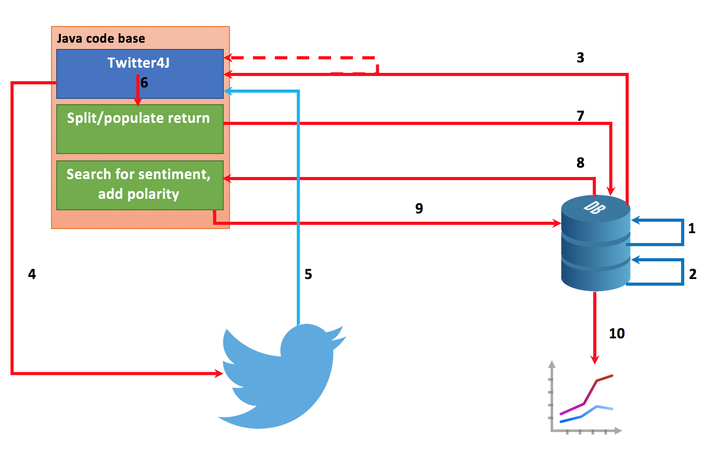

*figure 8: first iteration of the project architecture.*

*figure 9: final project architecture.*

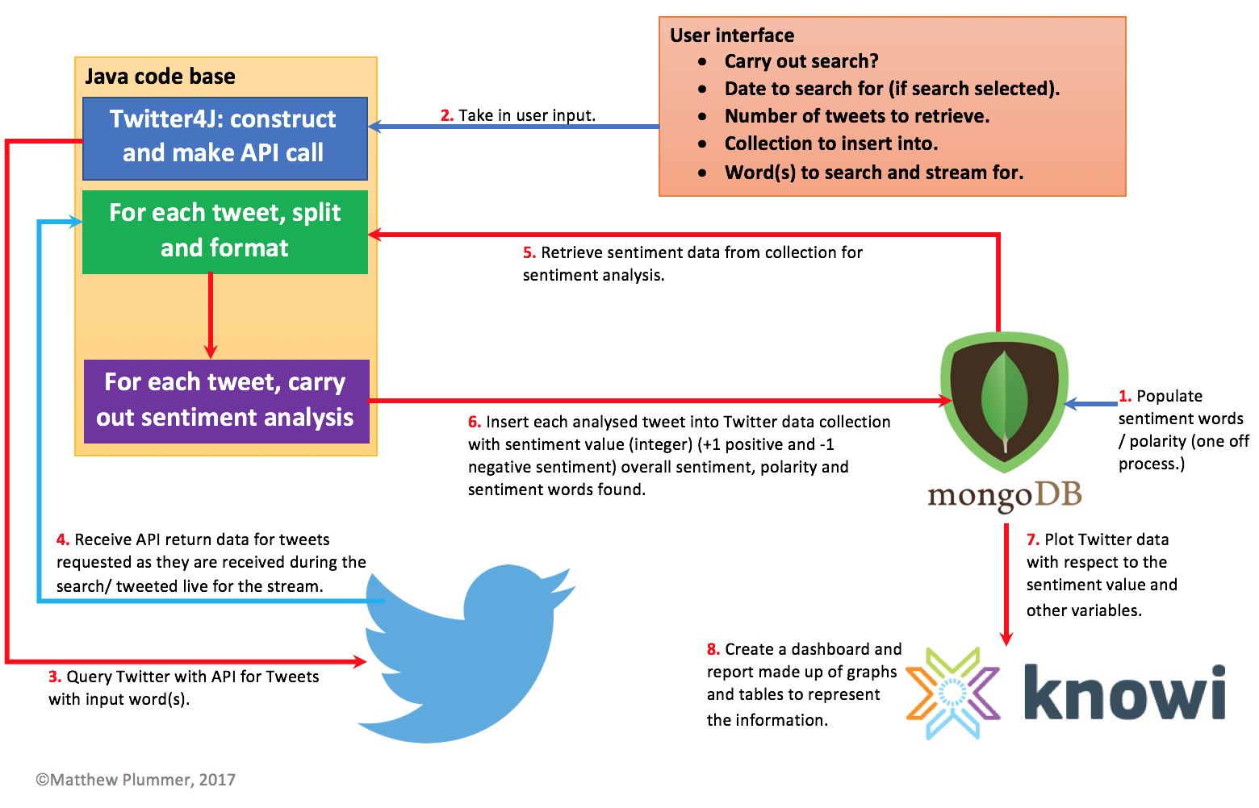

Below is an explanation of each step that can be seen in figure 9 above:

1. When initially running the project for the first time (upon setting up), a set of scripts are run on the MongoDB database. These scripts populate the ‘Sentiment’ collection with the sentiment words which needed to analysis the tweets. The set of over 2,000 positive[9] and over 4,000 negative[10] words were collected from a sentiment data project with the owner (Liu & Hu, 2015) allowing public use of this data.
2. After the initial setup above, the user runs the code. They are presented with an U.I. where they can specify parameters, examples being; number of tweets to retrieve, word(s)/ hashtag/ phrase search for, carry out a search with the stream or not and the collection to insert into. Once the user executes the application this information is used to customise their Twitter API call. The U.I. can be seen in the appendices of this report under appendix B.
3. The API is constructed based on the user’s parameter from the U.I. and Twitter is queried using theses constraints. This can either be a search API, stream API or both depending on the user selection.
4. The returned Twitter data is sent back to the Java code in the API return value. In the case of a search, the tweet data will be returned in batches with multiple batches being returned based on the number of tweets and the API window allowance. Contrary to the search process, for the stream, a listener is added to Twitter using the API call. This will return tweets one at a time as they are tweeted.
5. At this point the sentiment data, which was populated during the project set up, is retrieved. This is done once per execution which ensures new sentiment words are retrieved on each execution of the application by the user. The tweets are then processed in the Java code using these sentiment words and assigned an overall sentiment value (which is explained in the ‘Analysing tweets for sentiment’ section of this report).
6. All the tweets which have been analysed are inserted into the specified collection populating the fields for ID, overallSentiment, sentimentFound, simplifiedTweetDate, tweetDate, tweetText and tweetPolarity. The tweets are inserted one by one, this is done due to the fact that it is the fastest operation to carry out on the database when compared to other operations such as ‘update’.
7. All data which has been inserted into the collection from point 6 is visualised using graphs, charts and tables created in Knowi. In the case of visualisations which have already been created, the new data is added to this and visualised in accordance to the current visualisation(s).
8. All graphs, charts, tables and other visual creations of the data are added to a dashboard. This simply serves the purpose to have all information located in one place for a benefit to the user.

# Chapter 9: Using Twitter API system

Twitter has native support for API users. Twitter has their own API system which can be accessed by users allowed to do so. Almost anyone can use this API to retrieve information from Twitter via an API call, as opposed to via their website. Twitter splits its API service into a number of sections/ designated purposes these include, but are not limited to, search and streams (both of which this project used). How twitter manages its status and where this can be found can be seen in appendix F1 of this report. The process for using this to debug is also explained here.

Each user must create a Twitter Application[11] online with an existing Twitter account if they wish to use Twitters features i.e. posting a tweet, as you cannot post to Twitter without a user to do so. On the other hand, there is application-only API requests which means your application makes API requests on its own behalf, without a user. In both cases, they are rate limited meaning if either makes a request they both take from the same pool. This means that the limit is applied to the larger application as a whole, rather than on a per user bases. From within this created app a set of consumer keys (consumer key and consumer secret) and access tokens (access token and access token secret) are generated. This is required in order to make an API request to Twitter from an external programme. All four were required for this project.

# Chapter 10: Twitter4J code

In order for the Twitter4J code to function correctly the access tokens and consumer keys mentioned previously had to be added into a properties file in which the Java code can access and use in order to establish a connection to the Twitter API. This project used the approach where in the OAuth information was added to a properties file, however, this is not the only way. Twitter4J recommends hard coding the keys and tokens into the classes themselves. After considering both approaches it was decided that the latter approach was not a viable option. The reasoning behind this decision is due to the fact that the project was required to be multifunctional, meaning that the application has the ability to carry out both a search and a stream on Twitter. Thus, having the OAuth code in each class that is required causes unnecessary code duplication with sensitive information being present in the code. In storing the keys and tokens in a separate designated properties file allowed Twitter4J and the corresponding Java code to read and use this information from a single location.

## 10.1 Filtering requests

As mentioned previously in this report, the API calls can have filters applied to them. This allows the user to refine down the data retrieved from Twitter via the API. In the case of this project, the user has the functionality to select the search phrase/ word(s)/ hashtag to search and stream for, as well as the date to carry out a search on. These parameters can be inputted via the user interface for the application. Twitter tweets produce a lot of data with regards to the tweet. Some information that the tweets contain, but are not used in this project, are geo location which denotes the geographical location from which the tweet was tweeted and username which shows the Twitter handle of the user whom tweeted it (starts with ‘@’). This project does not request all Twitter information from each tweet. The important information that is required was requested and extracted. This information is named in the code with an explanation of each listed below:

* tweetText – the text of the tweet i.e. the 140 characters.
* tweetDate – the date the tweet was tweeted down to second granularity.

From the above two details from each tweet the following was extrapolated and calculated:

* simplifiedDate – tweetDate reduced down to day granularity i.e. ‘dd-MM-yyyy’.
* tweetPolarity – the overall sentiment shown in the tweetText with the possibilities being positive, negative, neutral and balanced.
* overallSentiment – this is a number value which denotes how positive or negative the tweetText is.
* sentimentFound – a comma separated list of matching sentiment words present in the tweetText.

Within the Java code the tweets to request are filtered. The search and stream functionality both request the same information and do so in similar ways with slight differences. Code snippets of this with a detailed explanation can be seen in appendix E1 of this report.

Twitters API system does have some restraints with regards to dates to conduct the search for. The date can be specified, however the time of the date cannot. This is a hard limit implemented by Twitter and as a result, when conducting searches on past dates the tweets will all originate from midnight on that date. If the user conducts the search for the current date, the search will retrieve tweets beginning from the time of execution i.e. the current time, looking back into the past from the current time. Twitter API will only store tweets from 6-9 days into the past, therefore, the search cannot be conducted on dates greater than 6-9 days into the past. If the user attempts this, no tweets will be retrieved.

The stream code applies a listener to Twitter with the filters mentioned above and the fitered explained in appendix E1 added. This is represented on the lines within the code that read ‘twitterStream.addListener(listener)’ and ‘twitterStream.filter(tweetFilterQuery)’. The Twitter listeners purpose is to do just that, it ‘listens’ for incoming tweets being tweeted based on the filter criteria set. If a match is found for the tweet the requested information is returned.

## 10.2 Making requests (stream)

As mentioned in the previous section, in order to access the streaming API for Twitter, a listener is added. With regards to the streaming functionality of this software the user defines a few parameters, these parameters being:

* Number of tweets to retrieve.
* Word(s)/ phrase to present in tweet to retrieve.

These two parameters are read into the code via the users input from the user interface upon running the application.

Twitter4J has its own native predefined code to set up and run tweet streaming. All of the reserved words and functionality is usable upon the implementation of the Twitter4J library. In order to access the Twitter4J libraries an import statement is needed, this statement being ‘import twitter4j.*’ which will import all Twitter4J functionality. Detailed code will specific lines for this process are explained/ shown under appendix E2.

From within the class shown in appendix E2 several checks are conducted. Firstly, the tweet that was retrieved is checked to determine if it is a retweet. For this project retweets were not considered in the streaming functionality and therefore were not used for the sentiment analysis. This is due to the fact that original opinions were more valued that the repeated opinions of others. In doing this the ‘sheep’ phenomenon was eliminated, by this it is meant that other Twitter users may retweet a tweet simply due to the person who originally posted the tweet whether they fully agree or not with their opinions that are being expressed. Considering retweets for the overall sentiment analysis was considered and trailed at the beginning. It was found that Twitter users will retweet opinions they disagree with as well as those they agree with. They may do this for a number of reasons, one being to highlight the disagreement with the original users tweet by quoting the original tweet. As such the results were giving false positives and negatives and therefore it was decided that retweets should not be considered for the final analysis. If a tweet is deemed to be an original tweet, and not a retweet, the next check is conducted.

With each iteration through the ‘onStatus’ method, within this class, with a valid tweet, one is added to the overall number of tweets retrieved. This number is compared to the users inputted value for the desired number of tweets to retrieve, if the number has not yet been reached the tweet is processed. Otherwise, if the desired number of tweets to retrieve has been reached the Twitter stream, along with the listener, is terminated and the connection is closed due to the fact that this means the process is complete.

Twitter4J uses methods to extract information from tweets, methods ‘getCreatedAt’ and ‘getText’ will extract the time the tweet was posted, to the second granularity, and the text for that tweet respectively. Fail-safes for the project to ensure smooth reliable running, along with a code snippet for the same is explained in appendix E2.

## 10.3 Making requests (search)

If the user decided to conduct a search, either along with a stream or independently, the same search code is executed. The search code works differently from the streaming code but does have several similarities, namely the calls within the synchronized loops and the code to extract the specific information required from the tweet. This code can be seen below in figure 14.

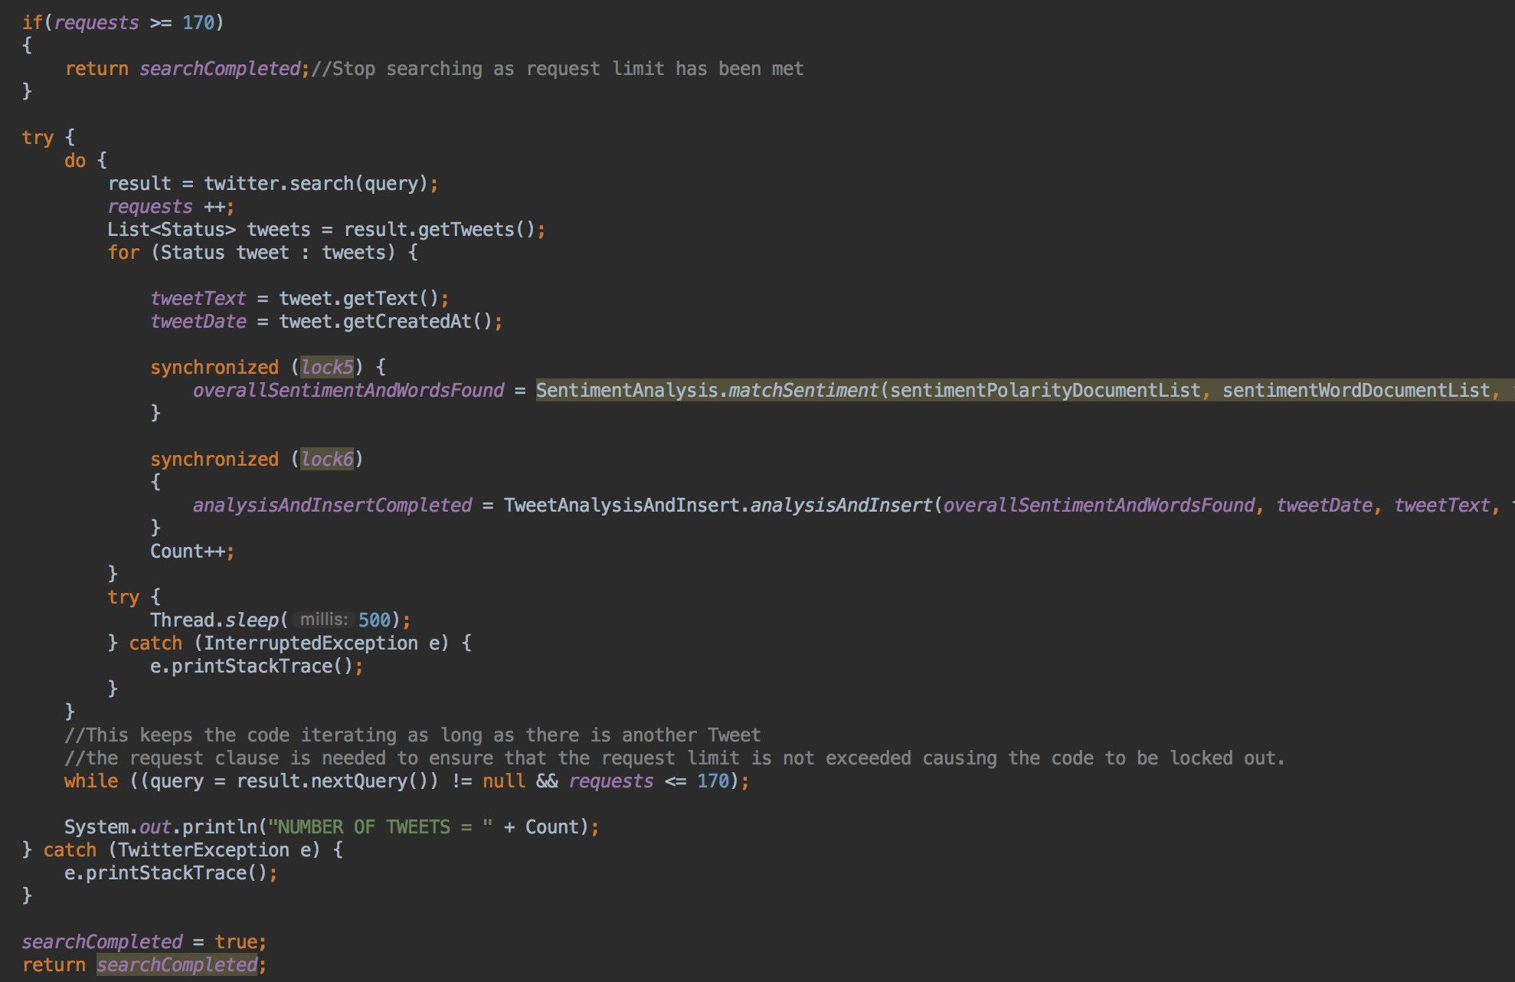

*figure 14: code for searching for tweets from Twitter via the Twitter API using Twitter4J.*

When conducting a search on the Twitter API, the number of requests being made must be considered. The Twitter API allows up to 180 requests per 15-minute window per user. If this value (rate limit) is exceeded, the user will be locked out of the Twitter API with no other requests being allowed for 15 minutes. If the user continues to exceed the rate limit, the user and their keys and tokens being used for access to the API can be blacklisted. If this is the case they will be locked out indefinitely and must contact Twitter support to unlock their user. Taking this into consideration, some form of limitation had to be put in place within the application. This limitation can be seen in the code snippet in figure 14. Adding the clause to check if ‘requests >= 170’ allows for the code to be terminated before the rate limit is exceeded. With each iteration through the while loop, one is added to the total number of requests. The number of requests is set to 170, even though the limit is 180, to allow a buffer between the number of requests executed and rate limit which Twitter allows. In doing this and allowing the buffer, lets the user continue to use the stream functionality even though the search cannot be used. Upon the initial execution of a search from the start of the application, a 15-minute timer is started. This timer acts as the window in which Twitter allows the 180 requests. When the timer reaches 0 the number of requests conducted is returned to 0 as the window has closed and new one has opened.

The search functionality of Twitter4J will retrieve tweets in batches, maxing out the number of tweets that can be retrieved within each request. As long as there are more tweets to retrieve and the number of requests does not exceed the limit, the search while loop will continue to iteration and retrieve tweets. With each iteration, the functionality will sleep for 500 milliseconds. This does not cause misses/ gaps in tweets retrieved, it is used to ensure the entire process of retrieving the tweets in the batch in completed before moving on the next. This functionality also prevents overlaps in tweets retrieved which could result in duplicates being inserted and therefore skewing the analytical results. Individual lines of code are explained in appendix E3. Within this the reserved functionality for Twitter4J in relation to searches are described in detail.

## 10.4 Making requests (both)

In order for the code explained previously to execute a call must be made to these classes. These calls branch from the core class which is called every time upon execution of the application. This class is the ‘DatabaseConnection’ class, details on this class can be found in the ‘MongoDB code’ section of this report. After a connection is established to the cluster and the collection is created or retrieved the code in figure 15 is executed calling the classes in figures 13 (see appendix E2) and 14. A number of variables are passed to these classes with a check being conducted to determine if the search functionality has been requested by the user which can be seen in the ‘if’ statement.

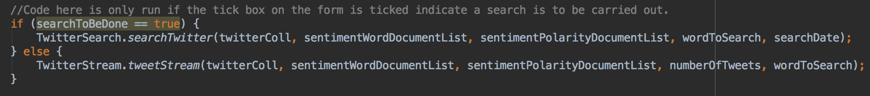

*figure15: code which is executed from within the ‘DatabaseConnection’ class to run the classes required to retrieve data from Twitter.*

# Chapter 11: MongoDB code

To reiterate, MongoDB is being used for this project in order to store raw and analysed data as well as the source of the sentiment words needed for sentiment analysis of the tweets retrieved. More specifically MongoDB Atlas is used for this storage. MongoDB have developed a Java driver for developers so that connections to MongoDB services, such as Atlas, can be established within Java code and IDEs. This driver also allows the developer to execute queries on their MongoDB service or Atlas cluster as they would via the command console. The MongoDB Java driver for this project was implemented using Maven. Maven provides Java developers a tool to build and manage any Java-based project which can make the day-to-day work of the developer easier. Maven works by providing a uniform build system as explained by (Maven, 2017) it allows a project to build using its project object model (POM) and a set of plugins that are shared by all projects using Maven, providing a uniform build system. Once you familiarize yourself with how one Maven project builds you automatically know how all Maven projects build saving you immense amounts of time when trying to navigate many projects. MongoDB also offer Gradle support, both Maven and Gradle install code can be found on MongoDB’s GitHub[12]. All information and documentation in relation to the MongoDB Java driver can be found on the MongoDB website for the driver[13].

## 11.1 Connecting to MongoDB Atlas via Java code

With the MongoDB Java driver installed, MongoDB (and its features) can all be access via the Java code. Upon adding the Maven code to the POM file of my project in Intellij I was able to set up a connection to my Atlas cluster. In order to connect to an Atlas cluster, there are two approaches, connecting via the MongoDB shell and connecting using the URI connection string provided by the cluster, the latter is the approach used for this project. In addition to the information provided by the cluster, a number of cluster specific parameters are required for the URI connection string, these cluster specific parameters are:

* Password
* Username
* Port number
* Database name

How these are stored and used in the code can be seen in the ‘Security’ section of this report. A template for the URI connection string for MongoDB as stated by (MongoDB, 2017) is as follows:

mongodb://[username:password@]host1[:port1][,host2[:port2],...[,hostN[:portN]]][/[database][?options]]

This is how the connection is constructed within the Java class named ‘DatabaseConnection’ which can be seen in figure 16 below.

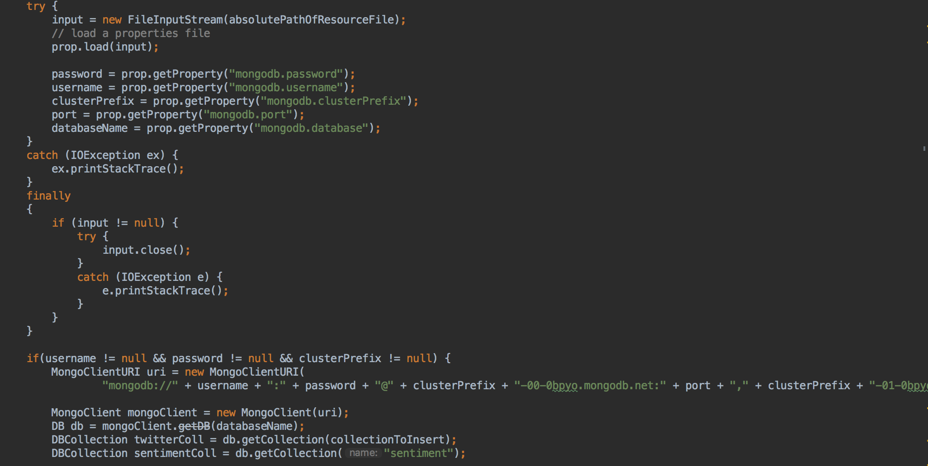

*figure 16: Database connection class showing the process to connect to the MongoDB Atlas cluster.*

Throughout the running of this application, this class is called multiple times. Each time the application is run a connection is made to the database in order to check for the selected collection, create a collection (if it does not already exist), to retrieve the sentiment information required for analysis and to insert the analysed tweets into the collection specified. In addition to this, a connection is made to the database in order to retrieve any new collections that may have been created, this is done upon the user clicking the ‘Refresh collection list’ button. After each process is complete i.e. a full cycle of retrieving, analysing and inserting tweets, the connection is terminated and a new one is established on the next execution. This is done to prevent unused connections being open to the database, which can result in connections not being able to be established (if the connection limit is reached) and also to help keep the database secure. With regards to terminating connections, this is not explicitly done within the code. MongoDB handles the termination of connections automatically and is done so when the connection is no longer needed. As a result, the Java code in figure 16 serves the purpose to make the connection.

The URI string, which is how the connection is made to the cluster, is constructed within the code when a connection is required. This is done by taking the users parameters (mentioned previously) from the properties file they have created or edited and substituting these into the string. This can be seen in the lines of code in figure 16 where the password, username, port etc. are being set to a value which is read from another file. When the MongoDB Java driver was installed into the project POM file, this allowed access to the MongoDB methods required to establish a connection to the cluster. Inbuilt methods are therefore used to construct and make the connection. This can be seen in figure 16 on the code lines:

‘MongoClientURI uri = new MongoClientURI(…);’

‘MongoClient mongoClient = new MongoClient(uri);’

‘DB db = mongoClient.getDB(databaseName);’

Following the above three lines of code, is the code which retrieves the sentiment collection (which contains all the sentiment words) and the collection which the user selected to insert the analysed tweets into. If the user decides to create a new collection and do so via the user interface, this is the point in which the collection is created. When the collection is created, it is merely a shell with nothing in it. There are no keys or values as these are populated and created upon the insertion of the document after the tweets have been analysed. These lines of code that are mentioned are as follows:

‘DBCollection twitterColl = db.getCollection(collectionToInsert);’

‘DBCollection sentimentColl = db.getCollection("sentiment");’

## 11.2 Inserting into MongoDB Collection on Atlas via Java code

Once the tweets which have been retrieved, either from conducting a search or a stream, they are analysed (details of which can be seen in the section ‘Analysing tweets for sentiment’). Upon the completion of the analyse the tweets are to be inserted into the user selected collection. The collection they are inserted into is then used to construct graphs, charts, tables and more via Knowi. The insertion process is the same for both the tweets retrieved via the stream and via the search and as a result both call the same class executing the same functionality for each insertion. The code snippet in figure 17 shows the code executed to carry out the insertions with an explanation following.

*figure 17: code snippet showing the insertion process for analysed tweets.*

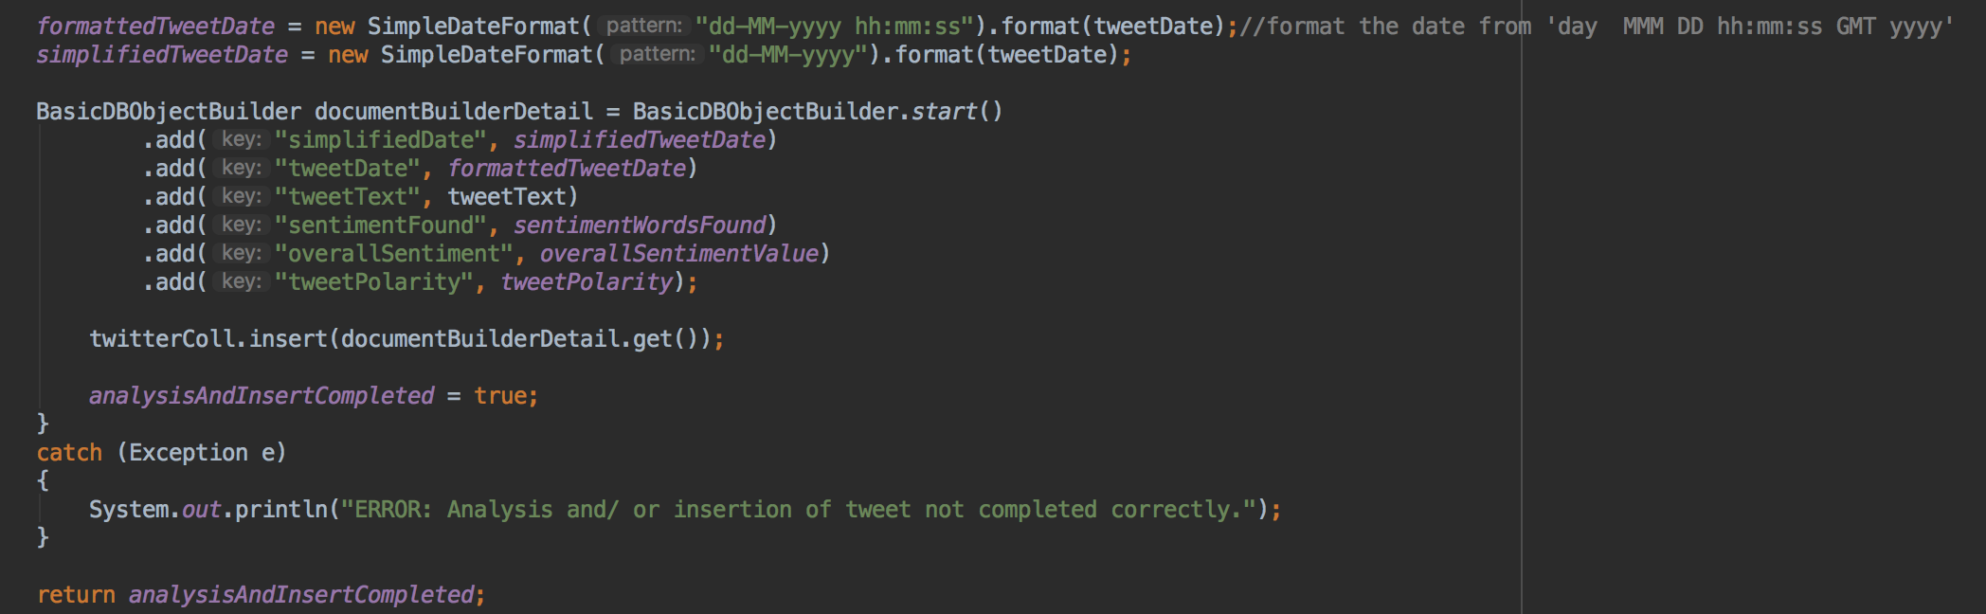

The first two lines of code seen in figure 17 shows how the simplified date, mentioned in a previous section of this report, is created from the date extracted from the tweet retrieved from Twitter. As Twitter tweets have the date in the format of ‘day MMM hh:mm:ss yyyy’ this first had to be transformed into a format more suited for analysis and visual representation. Therefore, this default date format is changed to match the format ‘dd-MM-yyyy hh:mm:ss’ this is the first date that is inserted into the collections and offers a second granularity analysis of the tweets. However, if a more general less granular visualisation is to be created this is not the best format to use. Due to this fact, the date was simplified to the day granularity. This date format is ‘dd-MM-yyyy’. In doing this, analysis can be carried out showing trends over days as opposed to seconds. These two dates mentioned are both stored in the collection and are used for further analysis and visualisations in Knowi.

The insertion process is carried out on an individual tweet bases. This means that one tweet is inserted at a time. The insertion of the tweet occurs after the sentiment analysis has been completed resulting in an overall sentiment and polarity being assigned to that tweet. This decision was made to carry out insertion one tweet at a time after the testing of batch inserts of tweets. In doing batch inserts it was found that during an insertion the collection is locked with the data being inserted not showing until the completion of the insertion. This meant that if there was a particularly large number of tweets retrieved and analysed, the insertion could take a long time to execute and complete. This resulted in the user not being able to see any information with regards to the new analysed tweets until the insertion was completed. Depending on the number of tweets this varied from a few minutes to an hour. In light of this testing, it was decided to insert tweets individually as they were analysed. This meant that the user could see analysed tweets throughout the process is a mocked live feed of tweets similar to the stream executed to get the live tweets.

The user could then carry out further analyse on the partial results before the entire process had been completed. This increased productivity and meant results and graphs could be created much more quickly in comparison to the batch insert approach. Temporarily there was a concern of the speed of this process aimed towards the fact that tweets may be missed from the live stream due to the time taken for the analyse and insertion of each tweet individually. Due to this concern, this was tested with the results showing that no tweets from the stream are missed. This is due to the fact that the entire process of analysing and inserting the tweets is a matter of milliseconds. The Twitter4J stream also does not stop while the analyse and insertion is being carried out. As the stream continues to run, live tweets are still being retrieved and sent to be analysed and inserted. This resulted in steady stream/ work load for the analyse and insertion processes, which are handled effectively with no loss of information.

The process to insert the tweets can be seen in figure 17. An object builder is used to add the keys and values to be inserted with a simple insert method being called at the end of the construction in order to execute the insertion to the collection. The insert method is another feature which is accessible via the MongoDB Java driver. The variable ‘twitterColl’ is the collection within the database cluster which is to be inserted into. This variable is determined by the user from the user interface upon execution of the application.

# Chapter 12: Analysing tweets for sentiment

Analysing tweets returned from both the search and stream of Twitter is at the core of this project. As mentioned previously in this report a collection of over 6,000 sentiment words are used to carry out the matching and checking of the presence of sentiment in a tweet. This is done by looping through all the sentiment words and comparing it to the tweet text retrieved. This process is done on an individual tweet bases similar to how the insertion is also conducted. Upon running the application, the sentiment words are retrieved from the sentiment collection in the cluster. The data needed for the sentiment analysis is retrieved in two parts. One gets the sentiment words and the other gets the polarity of the sentiment words. The code for this is split across two classes named ‘GetSentimentWords’ and ‘GetSentimentPolarity’ for retrieving the sentiment words and sentiment polarity respectively. These classes are very similar with a slight difference. The difference is that in order to get the sentiment word the collection is filtered on the key name ‘word’ whereas in the class for getting the polarity it is filtered on the key name ‘polarity’. In both cases the results are written to an array list. An example code snippet can be seen in figure 18. This snippet shows the code for retrieving the sentiment words from the sentiment collection.

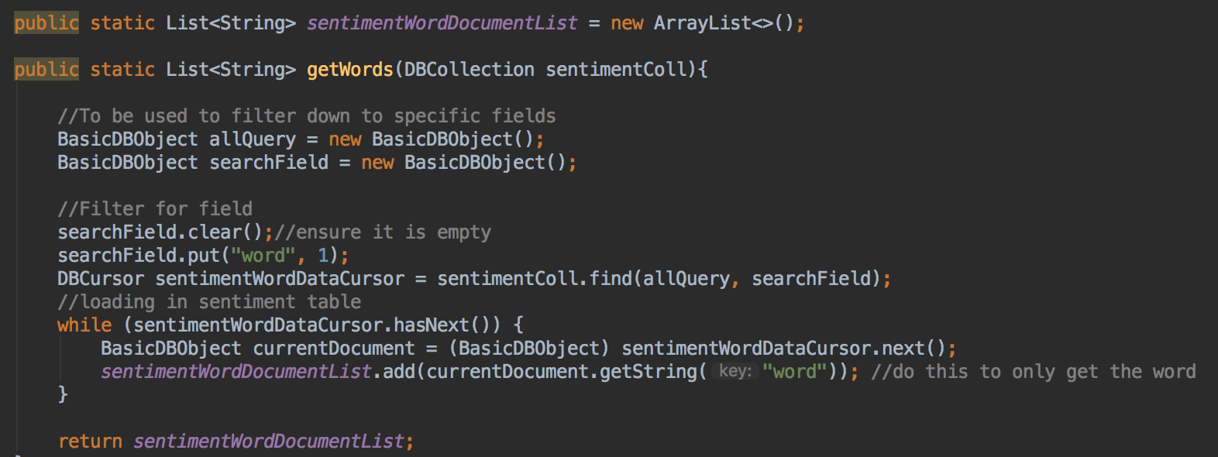

*figure 18: code snippet showing the retrieval of the sentiment words from the sentiment collection.*

During this process, it was important to keep the order of the results in the array lists in the correct order. This means that as the array lists are indexed at 0, the first sentiment word is inserted into index 0, the second into index 1 and so on. When the polarities are then retrieved the polarity for the first word is inserted into index 0 of the polarity array list, the polarity for the second sentiment word is inserted into index 1 and so on. In doing this, when the sentiment analyse is being carried out and the sentiment words are being iterated through the corresponding polarity is also retrieved. This iterative process can be seen in figure 19.

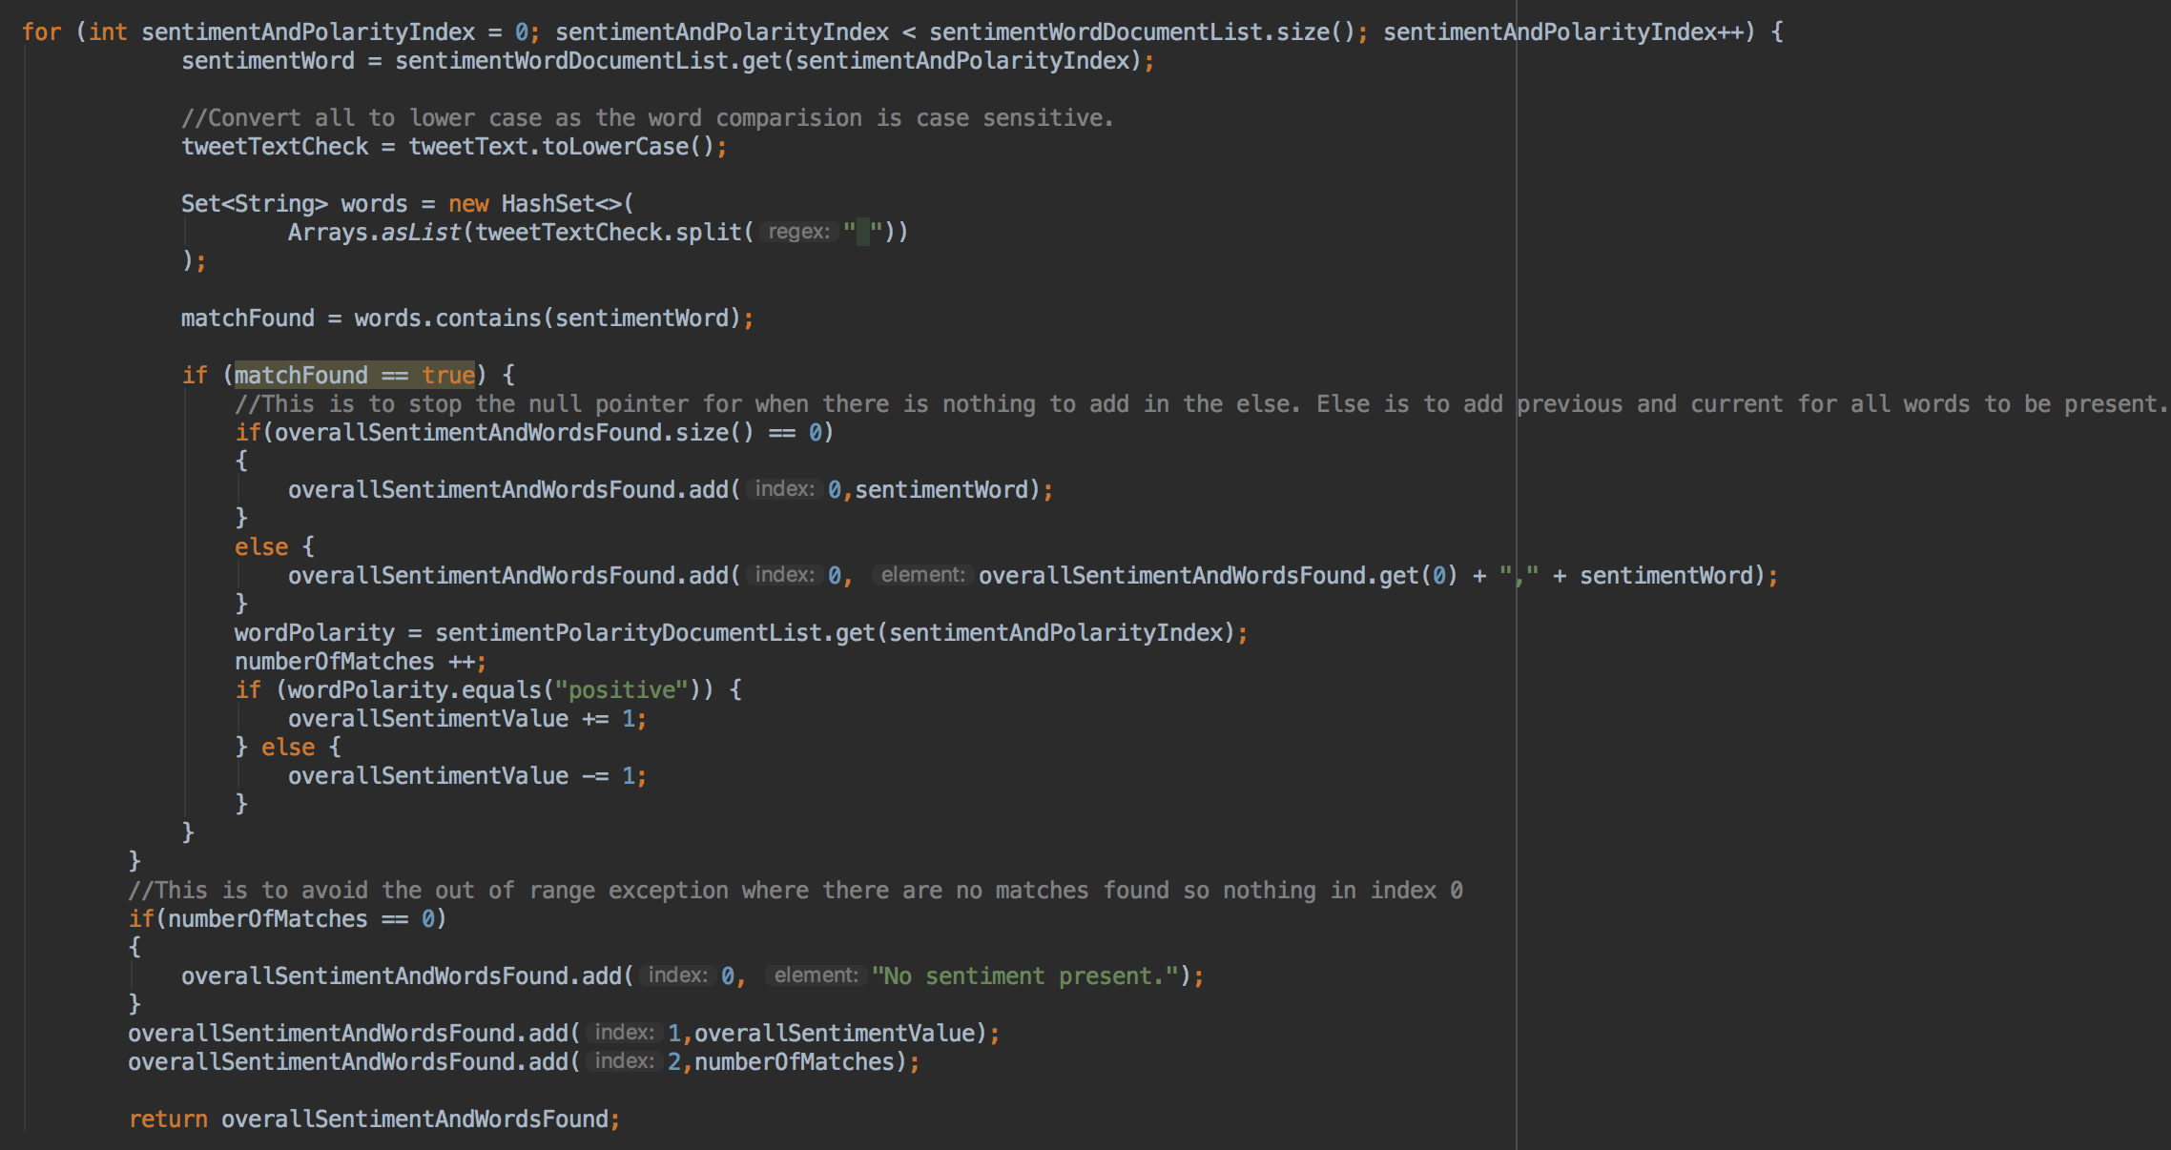

*figure 19: code snippet showing the process of sentimentally analysing the tweets retrieved.*

In the code snippet shown in figure 19 the iteration through the two array lists can be seen. Each tweet is taken into this loop as this classes method is called from the ‘TwitterStream’ and ‘TwitterSearch’ classes. Therefore, the method shown in figure 19 is called with each tweet received. All sentiment words will be iterated through and compared to the text of the tweet received. At this point the tweet text is converted to lower case to prevent any case sensitive mismatching of sentiment. If a sentiment word is found in the tweet, and only if it is found, the corresponding polarity is retrieved. This is done to save time and computation if the sentiment word is not found. After the polarity of the sentiment word is retrieved it is checked to determine if it is positive or negative. If it is positive 1 is added to the overall sentiment value otherwise it is negative and 1 is subtracted. Sentiment words that are found to be present in the tweet are recorded in a field within the document in a comma separated format, this is also inserted into the collection for further analysis. The overall sentiment is an integer representation of how positive or negative a tweet is, it is broken down as follows:

* By default, the overall sentiment of all tweets is initially 0.
* If a positive sentiment is found the overall sentiment is increased by 1.
* If a negative sentiment is found the overall sentiment is decreased by 1.
* After all sentiment words have been checked against the tweet, a polarity is assigned to the tweet. If the overall sentiment is:
  + Greater than 0 it is positive
  + Less than 0 it is negative
  + Equal to 0 zero, with no sentiment words present, it is neutral
  + Equal to 0, with sentiment words present, it is balanced.

A basic integer check, along with a string check, is carried out in the class that executes the insertion into the collection to determine the above overall polarities.

# Chapter 13: Security

The development of this project was done using Git and GitHub. A repository was created on GitHub at the beginning of the development process. This repository was made private on a private account. Access to the repository is secured using SSH connection. Keys are generated for the connection by the developer and this is used to carry out development work. The repository is also password protected, the repository cannot be access or cloned without a valid username and password.

This project deals with some potentially sensitive information in relation to the user of this application. Connection strings to the users MongoDB Atlas cluster are required to be present in the projects code in order to establish a connection. This connection string includes details including password, username, port and database name. These details are inserted into the project by the user before running the application. The details mentioned are therefore not present in the code they are used. There are no hard-coded details of this sort located in the code classes. All of these details are stored in a properties file which is located in a different location to the classes. The properties file for these details to make the connection are located in a separate folder (resources folder) in a separate location to all other code.

Other sensitive information includes the users Twitter API consumer keys and access tokens which are used to access Twitter’s API service. This information also needs to be secured as much as possible. As a result, the information is stored in a different file within the project. This file is not the same as that which has the information relating to the connection to MongoDB. These details are stored in a separate file in a different location to everything else.

This approach was taken due to the fact that if the code become compromised and an external source has access to the projects classes, the files containing the sensitive information will not also be compromised. The Twitter API information and the connection information are kept separate for the same reason, if one becomes compromised the external source does not have access to the other and vice versa.

MongoDB employ their own security with regards to their services. MongoDB Atlas clusters do not allow external connection to the cluster unless specified by an admin user. A connection to the cluster can only be established if the source IP address from which the user is trying to connect has been whitelisted. This prevents external unauthorised users from establishing a connection to the cluster.

# Chapter 14: Testing

Testing was conducted throughout the development of the project. Testing was carried out as new features were implemented and also when existing features were altered. These tests included the follow:

* Sanity testing: conducting a test on the functionality of the code to ensure the application still performs as expected.
* Feature testing: testing the individual testing of the feature that was implemented or changed to ensure it works as designed.
* Regression testing: testing the entire system from start to finish including all aspects i.e. streaming and searching to ensure the entire process works as expected as well as the individual parts working in conjunction with each other.

Specifically, the user interface was tested extensively after the completion of the core functionality of the application. The U.I. was implemented last and is crucial to the running of the project. The U.I. had constraints put in place to ensure the information the user enters is valid and will not result in errors upon running. Below is a table of tests which were conducted on the U.I. with an error message being displayed on the U.I. to show the user what the problem is.

|  |  |  |  |  |  |  |
| --- | --- | --- | --- | --- | --- | --- |
| Field on U.I. | Test for valid | Result for valid | Test for invalid | Result for invalid | Test for extreme | Result for extreme |
| Tick box for search | Box ticked/ unticked shows changes U.I. for specified functionality. | ✔: The correct fields were made available for both ticked and unticked. | N/A | N/A | N/A | N/A |
| Date field | Any date in the format ‘yyyy-mm-dd’ | ✔: Date was used for the code execution. | Any date not in the format ‘yyyy-mm-dd’ | ✔: An error message was displayed to the user asking for the date. | The date for the current day was inserted. | ✔: Date was used for the code execution. |
| Number of tweets for stream | The number 10 was inserted. | ✔: Code executed retrieving 10 tweets | This field was left blank and execution was attempted. | ✔: Error message was displayed to user asking for the field completion. | The larger number of 2000 was inserted. | ✔: Code executed retrieving 2000 tweets |
| Words to search or stream for. | The word ‘Trump’ was inserted. | ✔: Code executed retrieving tweets for the word ‘Trump’ | Nothing was inserted into this field. | ✔: Code did not execute and error was displayed to the user asking for field to be completed. | A number of words were inserted separated by commas. | ✔: Code executed using the multiple words inserted to retrieve tweets. |
| List of collections combo box. | A collection was selected from the list. | ✔: Tweets were inserted into the selected collection. | This field was left empty. | ✔: Code did not execute and an error message was displayed to the user asking for the fields completion. | A new collection that did not already exist was entered into the field. | ✔: The new collection was created and inserted into as expected. |

# Chapter 15: Post-mortem

The project as a whole was a success, the approach to the work was timed and planned well and the schedule was adhered to. Everything was completed on time and in a timely fashion to a high quality. The project structure was a good choice, the structure being to work on the software and code as a main priority with the report as a secondary concern. Additions were made to the report as the application was developed. This choice was made due to the details required to be present in the report, as highly detailed explanations of the software was required it was quickly found that the report was problematic to write without the full completion of the software.

The project management approach taken for this project was the correct one. This approach was the agile workflow model. This allowed the development of the project to run smoothly and adapt as it grew. The management of the code within the project was also very well done with all code being version controlled. In using Git as a version control platform, past work and alterations made to the project could be checked. This was done several times throughout the development.

Having regular meetings with the project supervisor, and other members of faculty within the university, was a decision that proved to be vital. Having regular meetings allowed me to gain valuable feedback on the project and how it was progressing. Getting others points of view and ideas during these meetings proved to be extremely advantageous.

With regards to the technologies used, they were not decided upon lightly. Extensive research was carried out on all the technologies used within this project and the advantages and disadvantages of each were assessed to determine the most suitable for the project idea.

The performance of myself on this project was slow to begin with but quickly gained speed as development progressed. There was a huge learning curve in all the technologies used for this project as going in to this I had no prior knowledge of the topic area or the technologies in use. I had an understanding of Java code but not with the integration of Twitter4J. With regards to MongoDB, I had never developed using a NoSQL database model or MongoDB. In saying this, an immense amount of knowledge was gained with the majority of it being self-taught. In hindsight, it was a poor decision to use technologies that I had no experience in for all aspects of this project. It may have been more beneficial and practical to use at least one technology I am proficient in.

In looking back, I found that the objectives and aims of this project were known on a quite detailed level but could have been much more refined. This would have helped with the understanding of what the project was trying to achieve and what the overall outcome was. Upon starting the project there were few objectives in place and these were slowly added to and built upon during the development of the project. This was a bad decision and all objective, aims and deliverables should have been outlined prior to the beginning of development.

# Chapter 16: Conclusions

In the end the project accomplished what it set out to do. The project developed into a fully functional sentiment analytical tool for Twitter. In having this basis of basic sentiment analysis, it can now be further developed into a more accurate representation of sentiment analysis. Some areas to be worked on are to:

* Take into account the context of the tweet.
* Understand how to implement human language to the sentiment of the tweet.
* Implement a more precise method of calculating overall sentiment of tweets.

There were a few issues during the development process which did slow progress, but nothing detrimental was encountered.

Sentiment analysis conducted in this project achieved the goal of providing and overview the publics opinion as a whole of a certain topic area. The application did allow the user to have as much customisable options as possible in the sense of having the flexibility to conduct searches and/ or streams on specific key words/ phrases.

The user is able to construct their own graphs, charts and tables on the data sets to gain information tailored to what they require. This was one of the objectives of the project, and this objective was met.

The project runs smoothly and completed the job that it is required to do at the user’s command with the results produced being accurate.

In summary, the project was an overall success with all requirement, objectives, aims and deliverables being met on time and in a timely manner.

Statement of word count: 10,964

# Works Cited

Balasubramanyan, R., O’Connor, B., Routledge, B. R. & Smith, N. A., 2010. *From Tweets to Polls: Linking Text Sentiment to Public Opinion Time Series,* Pittsburgh: School of Computer Science and Business Carnegie Mellon University.

Bannister, K., 2016. *Understanding Sentiment Analysis: What It Is & Why It’s Used.* [Online]   
Available at: https://www.brandwatch.com/blog/understanding-sentiment-analysis/  
[Accessed 26 March 2017].

Cloud Carib, 2016. *Cloud Storage vs. Cloud Computing: What’s the Difference?.* [Online]   
Available at: http://info.cloudcarib.com/blog/cloud-storage-vs.-cloud-computing-whats-the-difference  
[Accessed 24 March 2017].

George, C.-S., 2015. *How Much Data Is Generated Every Minute On Social Media?.* [Online]   
Available at: http://wersm.com/how-much-data-is-generated-every-minute-on-social-media/  
[Accessed 22 March 2017].

Guess, A., 2011. *The Possibilities and Limitations of Sentiment Analysis.* [Online]   
Available at: http://www.dataversity.net/the-possibilities-and-limitations-of-sentiment-analysis/  
[Accessed 11 April 2017].

Internet Live Stats, 2017. *Twitter Useage Statistics.* [Online]   
Available at: http://www.internetlivestats.com/twitter-statistics/  
[Accessed 22 March 2017].

Knowi, 2017. *Knowi.* [Online]   
Available at: www.knowi.com  
[Accessed 5 April 2017].

Liu, B. & Hu, M., 2015. *Opinion Mining, Sentiment Analysis, and Opinion Spam Detection.* [Online]   
Available at: https://www.cs.uic.edu/~liub/FBS/sentiment-analysis.html  
[Accessed 11 April 2017].

Maven, 2017. *Maven.* [Online]   
Available at: https://maven.apache.org/what-is-maven.html  
[Accessed 15 April 2017].

MongoDB, 2017. *Connection String URI Format.* [Online]   
Available at: https://docs.mongodb.com/manual/reference/connection-string/  
[Accessed 16 April 2017].

MongoDB, 2017. *MongoDB Atlas.* [Online]   
Available at: https://docs.atlas.mongodb.com/  
[Accessed 24 March 2017].

MongoDB, 2017. *MongoDB Compass.* [Online]   
Available at: https://docs.mongodb.com/compass/master/  
[Accessed 24 March 2017].

PaCroffre, 2012. *Social Media, Companies and Data Volumes.* [Online]   
Available at: http://it.toolbox.com/blogs/patricks-it-toolbox/social-media-companies-and-data-volumes-51872  
[Accessed 22 March 2017].

Rouse, M., 2013. *Google Trends.* [Online]   
Available at: http://whatis.techtarget.com/definition/Google-Trends  
[Accessed 7 May 2017].

Rouse, M., 2015. *NoSQL DBMS (Not only SQL database management system).* [Online]   
Available at: http://searchdatamanagement.techtarget.com/definition/NoSQL-DBMS-Not-only-SQL-database-management-system  
[Accessed 25 March 2017].

Rouse, M., 2015. *NoSQL DBMS (Not only SQL database management system).* [Online]   
Available at: http://searchdatamanagement.techtarget.com/definition/NoSQL-DBMS-Not-only-SQL-database-management-system  
[Accessed 24 March 2017].

Statista, 2017. *Number of monthly active Twitter users worldwide from 1st quarter 2010 to 4th quarter 2016 (in millions).* [Online]   
Available at: https://www.statista.com/statistics/282087/number-of-monthly-active-twitter-users/  
[Accessed 26 March 2017].

Statista, 2017. *Number of social media users worldwide from 2010 to 2020 (in billions).* [Online]   
Available at: https://www.statista.com/statistics/278414/number-of-worldwide-social-network-users/  
[Accessed 26 March 2017].

Tech Terms, 2016. *API.* [Online]   
Available at: https://techterms.com/definition/api  
[Accessed 26 March 2017].

Twitter, 2017. *API Status.* [Online]   
Available at: https://dev.twitter.com/overview/status  
[Accessed 14 April 2017].

Twitter, 2017. *OAuth.* [Online]   
Available at: https://dev.twitter.com/oauth  
[Accessed 14 April 2017].

Twitter4J, 2017. *Twitter4J.* [Online]   
Available at: http://twitter4j.org/en/index.html  
[Accessed 26 March 2017].

# Appendices

## **User guide**

### **Software needed**

MongoDB Atlas: <https://www.mongodb.com/cloud/atlas>

MongoDB Compass: <https://www.mongodb.com/products/compass>

Knowi: <https://www.knowi.com/>

Intellij IDE: <https://www.jetbrains.com/idea/>

### **Java IDE**

It is recommended that Intellij is used as the IDE to run the programme. Other IDEs may be used if you wish, however, this user guide is tailored to the use of Intellij. A free version of the IDE can be downloaded via their website (see ‘software needed’).

### **MongoDB Atlas**

1. Navigate to the MongoDB Atlas website and choose the option of ‘Start Free’ if you do not already have an account with MongoDB Atlas. Otherwise, log into your account.
2. Create a cluster within Atlas using the free tier option.
3. Follow the instructions on screen to set up the cluster.
4. Add your IP address to the whitelisted IPs under the security section of the cluster.
5. Once the cluster has been created and is running click the button named ‘connect’. Make note of the URI string presented.
6. Paste this string to a text file (or other source to carry out editing) and replace the parameters for ‘password’ and ‘database’ with the appropriate details.

### **MongoDB Shell**

1. Click the connect button presented in the Atlas cluster as in the previous section.
2. Scroll to the bottom of the dialog to the section named ‘Connect with MongoDB Shell’.
3. Download MongoDB Shell as instructed in step 1 of this section of the dialog.
4. Follow the instructions in step two the dialog (including the link) to connect to the cluster via the shell.

### **Creating a database**

1. Once connected to the shell run the following command inserting the name of the database you wish to create:

use <databaseName>

1. To show the databases within this cluster run the following command (note: the database will not show if there are no documents present. At least one document has to be present for the database to be displayed.)

show dbs

1. Run the scripts in the following two file on the cluster within the database you have created, this will create and populate the sentiment collection.



### **MongoDB Compass**

1. Download the MongoDB compass application from the link provided in ‘software needed’ above.
2. Create a new connection within MongoDB Compass.
3. Paste the URI string into the connection box and complete other fields as required.

### **Twitter API**

1. Navigate to the Twitter app located here: <https://apps.twitter.com/>
2. Login/ create an account and create a new app.
3. Generate a set of access tokens and keys.
4. Take note of these keys and tokens.

### **Java properties**

1. Navigate to the Java code files.
2. Open the file named ‘mongoDbConnection.properties’, complete the variables within this file. The cluster prefix and port number can be found within the URI connection string.
3. Save the changes
4. Open the file named ‘twitter4j.properties’, complete the variables here with the access tokens and keys generated within the Twitter app.
5. Save these changes.

### **Running the code**

1. Run the Java file named ‘UserInterfaceProcess’.
2. Complete the form as required to what you require.
3. Execute the form.
4. Check MongoDB Compass for a high-level look at the data being retrieved and inserted into the collection.

Knowi

1. Navigate to the Knowi website located in the ‘software needed’ section at the beginning of this guide.
2. Create an account (which is free).
3. Select the option to connect via MongoDB.
4. Connect to the MongoDB Atlas cluster by doing the following:
   1. Enter the name of the database you are connecting to.
   2. Insert your username and password for the Atlas cluster (the user connecting to the cluster needs to have admin permissions).
   3. Enter the host name in the following format:

<cluster shard 0 name>.mongodb.net:<port number>,<cluster shard 1 name>.mongodb.net:<port number>, …

* 1. Set ‘Database Properties’ to the following:

ssl=true&authSource=admin

* 1. Untick the box for SSH tunnel.

1. Create charts and graphs using Knowi and add them to a dashboard. Instructions to use Knowi can be found here <https://www.knowi.com/docs/queries.html>

## **Highlights**

### **Highlight 1**

**PID**

* Completed PID and submitted it via SPMS
  + Fixed issues with the PID as point out by my supervisor.
  + PID was resubmitted and it met the requirements.

**Supervisor meeting**

* Had Second meeting with my supervisor.
  + First meeting was last term to establish a first contact.
* Discussed the project, next steps and milestones to hit.
* Determined to do the following broad topic areas in this order:

1. Collect data from Twitter
2. Look into storage of data
   1. Store the data in the way that was decided
   2. Analysis the performance of this and adjust if needed
3. Set up table of sentiment words
4. Carry out analytics on data set

**Notes**

* Started taking hand written notes in a notebook.
* Drew concept diagram before supervisor meeting to visualise what it I am trying to do. (Can be seen below)
* Hand written notes can be seen in the misc. folder on SPMS

**Concept diagram**

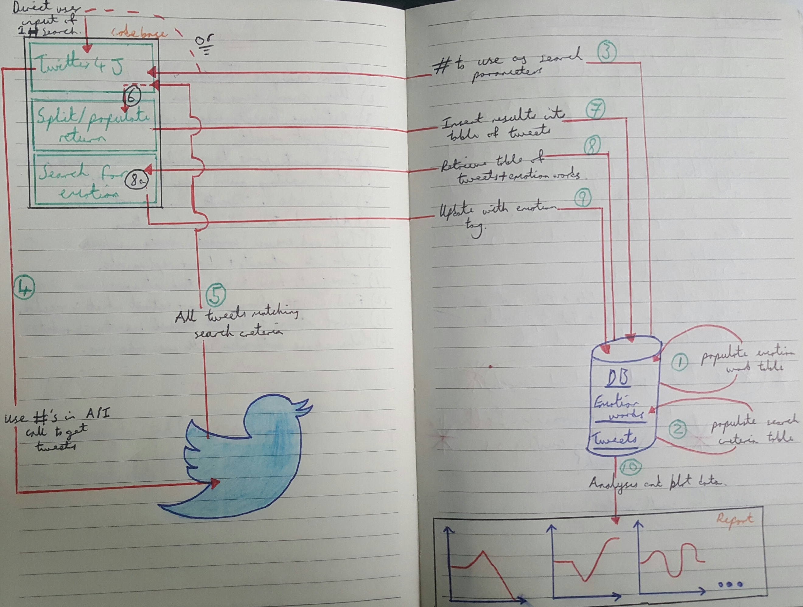

### **Highlight 2**

**Notes (all of which can be found in the MISC folder)**

* Continued to write notes which consisted of:
  + Research on Twitter4J
    - The process
    - How to get it
    - What else is needed for it
    - How it all works together
  + Questions to ask
    - General questions to ask supervisor and/or other lectures/ online.
    - Specific questions about API and the process of using Twitter4J.
    - Database storage i.e. Oracle, SQLite3 etc.
    - Integrating into my Intellij IDE.
    - Analytical tools to use.
  + Tasks to be carried out
    - Different tasks to undertake and carry out on Twitter4J.
    - What to do using the Twitter API.
    - Details on how to retrieve Tweets.
    - Different areas to look further into i.e. taking into consideration retweets, likes, replies etc.
    - How to understand the return.

**Meeting with Marco Palomino (Monday 13th February)**

* Discussed mainly using Twitter4J
  + Examples of what he has done in the past.
  + Accessing the examples supplied by Twitter4J.
  + Basic coding using Twitter4J.
  + Useful aspects of Twitter4J that may be used.
    - Tweet streaming
    - Tweet searching
* The Twitter API
  + How it is used.
  + When it is used.
  + How it works.
  + Limitations
    - The number of calls that can be made in a short period of time which means the number of tweets retrieved from searching is limited.
* Visualisation using Neo4J
* Found possible legal issue with taking data from Twitter (may be counted as internet research but it is unclear) this will be followed up to determine if the university legal and ethics document covers this or not.

**Coding**

* Started looking at the example Twitter4J found on their website.
* Created a new Java project to carry out my project.
* Added this to GitHub and integrated Git into my IDE so version control can be done from within the IDE.
* Created the keys needed to use Twitter4J.
  + Added these as the property files to my project.
* Made initial class to test the call-back of the API.
  + Wrote a basic method to test to ensure my keys worked.
* Once above was confirmed I started programming what was needed.
* Created a Twitter stream class which will retrieve live tweets
* Create Twitter search class which will search through past Tweets.
* Added filters for the stream class these filters are:
  + Only show Tweets that are in English (‘en’).
  + Only show tweets based on integrated hard coded search word(s)/phrase(s)
* Added filters for the search class these filters are:
  + Only show tweets based on integrated hard coded search word(s)/phrase(s)
* Printed the results of only the date of the tweet(s) and the text of the tweet(s).
* Writing results of the stream to a .txt file.

**To-do in relation to the above coding work**

* To added English filter to the search class.
* Make so only original tweets are returned not the retweets, likes or replies.
* Currently the .txt file is being overwritten with each iteration meaning only 1 tweet is written. This is to be fixed so the .txt file is only created once and is then added to not over written with new tweets.

### **Highlight 3**

**Code**

* Streaming Tweets
  + Changed code so it will create a file if it does not exist, if it does exist it will append to said file instead of overwriting as it did before.
* Searching Tweets
  + Made it so the tweets are filtered more.
    - Only show tweets in English.
    - Exclude retweets i.e. only show original tweets
  + Searched tweets are now written to a text file, the same as the streaming tweets class.

**Report**

* Started the report
* Created the cover page
* Wrote the acknowledgements (to be added to)

**Notes**

* Uploaded all hand-written notes so far to the SPMS misc. folder

**Database**

* Carried out some research of possible database storage options.
* Wrote down the structure of the tables needed i.e. the columns, names and datatypes.
  + Twitter Data
  + Sentiment
* Tried to use MySQL to create and store the tables.
  + Ran local instance on MySQL and tried to connect.
  + Locked out of accessing MySQL.
* Tried Postgres.
  + Tables created but now sure how to run or access the database.
* One of the two options should be fixed and used or other options should be looked into to determine if they are better fit.
* How can these integrate into Intellij IDE?
* How will this work upon submission if the database requires downloads and instances to be running in order to connect?

### **Highlight 4**

**Database continued**

* Researched further into database options on previous highlight i.e. MySQL and PostgreSQL, which was to no avail.
* Contacted Ismini Vasileiou with regards to using Oracle.
  + It was suggested to use new VPN client FortiClient in order to access the VPN required to connect to the University and access their Oracle servers.
  + This all worked fine and was able to integrate it into Intellij.
* After a one on one meeting with Ismini on 1st March it was suggested that I should look into other database solutions. The two main recommendations were:
  + Microsoft Power Bi which uses Microsoft Azure.
  + MongoDB
* The name of some columns has been altered from the previously posted notes so they better represent their purpose.

**Database alternatives**

* The Microsoft option quickly became not possible. Due to:
  + This application is only available on Windows machines (my project work is mainly done on a Mac).
    - It is possible to partition my hard drive to run a version of Microsoft Windows on a portion of my hard drive, which may not be the most efficient.
    - Alternatively, a virtual machine could be started on Microsoft’s cloud platform Azure with an instance on Windows. This can then be accessed and used to carry out the work. This however, may have a cost eventually in order to run the instance.
* Mongo DB as of yet is working as expected.
  + The latest version of Mongo DB has been downloaded and installed.
  + Mongo DB can be started through a shell command on the local host.
  + The local host can then be connected to in order to store, create and access databases.
  + A plugin is available for Intellij which allows Mongo DB to be visually available from within the IDE. As a result, Mongo DB seems like a via solution, however, there will be some learning to this as it is a new technology.

**Miscellaneous**

* The previously hand drawn architecture diagram has be recreated on a computer and can be seen below:
* A Tumblr blog has been created to document work on this project. This blog can act as a source for me to look back on, to monitor progress and to gain feedback on my ideas and solutions (if it gains followers.) The Tumblr blog can be found here <http://twitteranalytics.tumblr.com/>

### **Highlight 5**

**Database**

* Mongo Db was decided upon and will therefore be taken forward for this project.
* Research and self-teaching time was put in to understand the basics of Mongo Db
  + Terminology
  + Structure
  + Key aspects
  + Data storage
* As Mongo Db is being implemented via Java and integrated into my Java IDE time was also put into research and self-teaching of this aspects.
  + Integrating into IDE
  + Methods used
  + Connection from within IDE
  + Queries to run
  + Syntax of the java code structure for Mongo Db

**Programming**

* Mongo Db
  + Read in text file of tweet data
  + Specify all variables i.e. database, connection, collection, tweet date, tweet text etc. to be used later.
  + Stripped date of unneeded characters “]” and “[”.
  + Build up a document based on data from text file which is to be inserted to the collection.
  + Add all fields including fields not yet used (sentimentFound and overallSentiment) which are set to “NULL” here.
  + Insert all this data into the Mongo Db database collection specified.
* Twitter Stream
  + Commented code for ease of debugging in future and understanding.
  + Formatted the Tweet date from the ‘day MMM DD hh:mm:ss GMT yyyy’ to dd-MM-yyyy hh:mm:ss
  + Writing this new date format to text file instead

### **Highlight 6**

**Database**

* Sentiment collection/ table
  + Sentiment words have been populated along with their polarity (positive/negative.) There is a total of approximately 6,000 words made up of approximately 4,000 negative and 2,000 positive words which may need to be revised as it could skew results.
  + The links to these lists of words can be found here:
    - Positive: [http://ptrckprry.com/course/ssd/data/positive-words.txt](http://t.umblr.com/redirect?z=http%3A%2F%2Fptrckprry.com%2Fcourse%2Fssd%2Fdata%2Fpositive-words.txt&t=NmM2MDNlOTBlYjcyMTdhNTFjYTY1MWY2OTdlMWY0ZjFhMzlkZmM3NixsdUwwMzZmOQ%3D%3D&b=t%3AjtulFJKtsiil5PBraZWPCQ&p=http%3A%2F%2Ftwitteranalytics.tumblr.com%2Fpost%2F158155895927%2Fpopulating-sentiment&m=1)
    - Negative: [http://ptrckprry.com/course/ssd/data/negative-words.txt](http://t.umblr.com/redirect?z=http%3A%2F%2Fptrckprry.com%2Fcourse%2Fssd%2Fdata%2Fnegative-words.txt&t=MzQ0Y2EzYWY3OTYzNjE3Y2FkZGRkMzE5MzJiMjhlM2M5MWMxOTc0OCxsdUwwMzZmOQ%3D%3D&b=t%3AjtulFJKtsiil5PBraZWPCQ&p=http%3A%2F%2Ftwitteranalytics.tumblr.com%2Fpost%2F158155895927%2Fpopulating-sentiment&m=1)
  + This is a one-off process for the initial set up of the project.

**Programming**

* Twitter_data
  + Class has been to cycle through all the sentiment words and compare them to the Tweet’s text.
  + The data will be marked with an overall sentiment of >1 positive, <1 negative =0 neutral.
  + The polarity will be set for each Tweet based on that above.
* All functionality
  + The classes that were separate has now been made into one class with separate methods. This may not be the best approach so should be checked.
  + Values for the number of tweets to retrieve and the hash tag/ phrase to search has been parameterised. The user can now input the both of these manually via the console.
    - This could be made into an application with a UI.

**Cloud**

* Mongo Db Atlas
  + I have now migrated my database storage from my local machine to the cloud platform of Mongo Db called Atlas. Due to this the code for my project had to be changed in order to connect to this cluster and insert, read and update this cluster accordingly.
  + A cluster had to be created, IPs whitelisted and security implemented.
  + The java version of my project also had to be upgraded from Java 7 to Java 8.
  + The java Mongo Db driver for my project had to be upgraded to the latest via the maven pom.xml file.

**Analysis**

* Mongo Compass
  + I have implemented Mongo Db’s data visualisation and management tool Compass. This application allows me to see the percentage of each data value at a glance, when data was retrieved, how much data there is and to view the collections contents.
  + Compass allows you to filter on certain fields to see data more granuarly.
  + Currently I have only carried out this task with regards to Donald Trump mainly using the hashtag Trump.
  + Some of the data shown by Mongo Compass can be seen below:

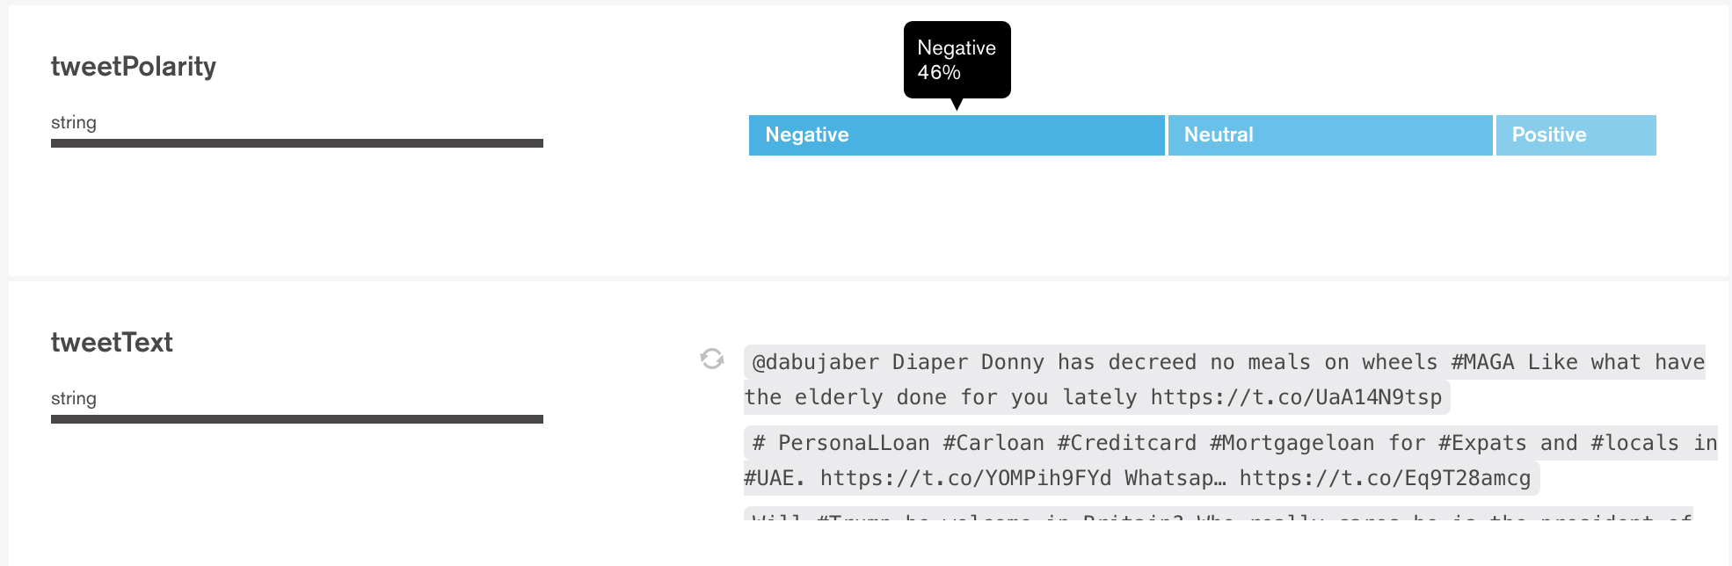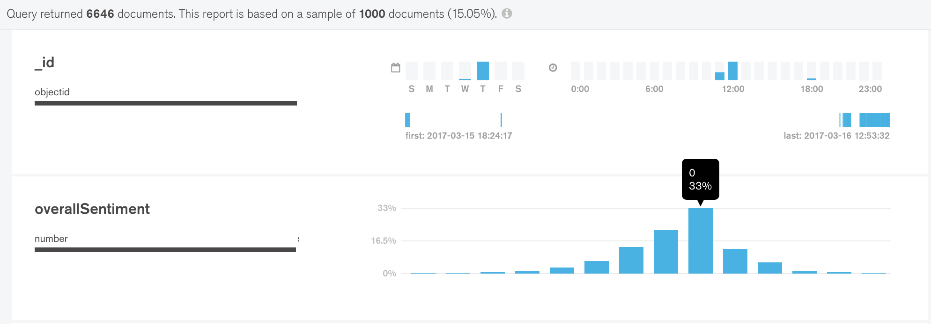

### **Highlight 7**

**Programming**

* Structure
  + Separated out the classes again due to best coding practice of each class/ method having a single purpose. This also help reduce clutter in code and make it much clearer to read and easier to understand.
* Performance
  + Some performance issues were being seen and slow analysis was experienced. This was due to the fact that I was analysing the entire collection each time at the end of the inserts. As a result, as the collection grew in size the time take to analysis it all increased also.
  + To resolve this issue, I first had to remove this functionality of analysing the entire collection with each run. To do this I decided to instead analysis the Tweets one by one as they are being retrieved. This meant a few things:
    - The analysis would be a lot quicker when compared to mass sentiment analysis.
    - This stops the entire collection being analysed with each iteration thus speeding up analysis.
    - A live analysis would be carried out so results can be seen as it is running. This is helpful if, for example, you retrieve 2,000 Tweets, this will take a while but as they are being analysed one by one it the analysis for Tweets can be seen throughout.

**Data**

* More data is now being produced in the form of matched sentiment words.
* This allows the comparison of the use of each sentiment word for all Tweets and see the most used word, most used combination, least used etc.
* 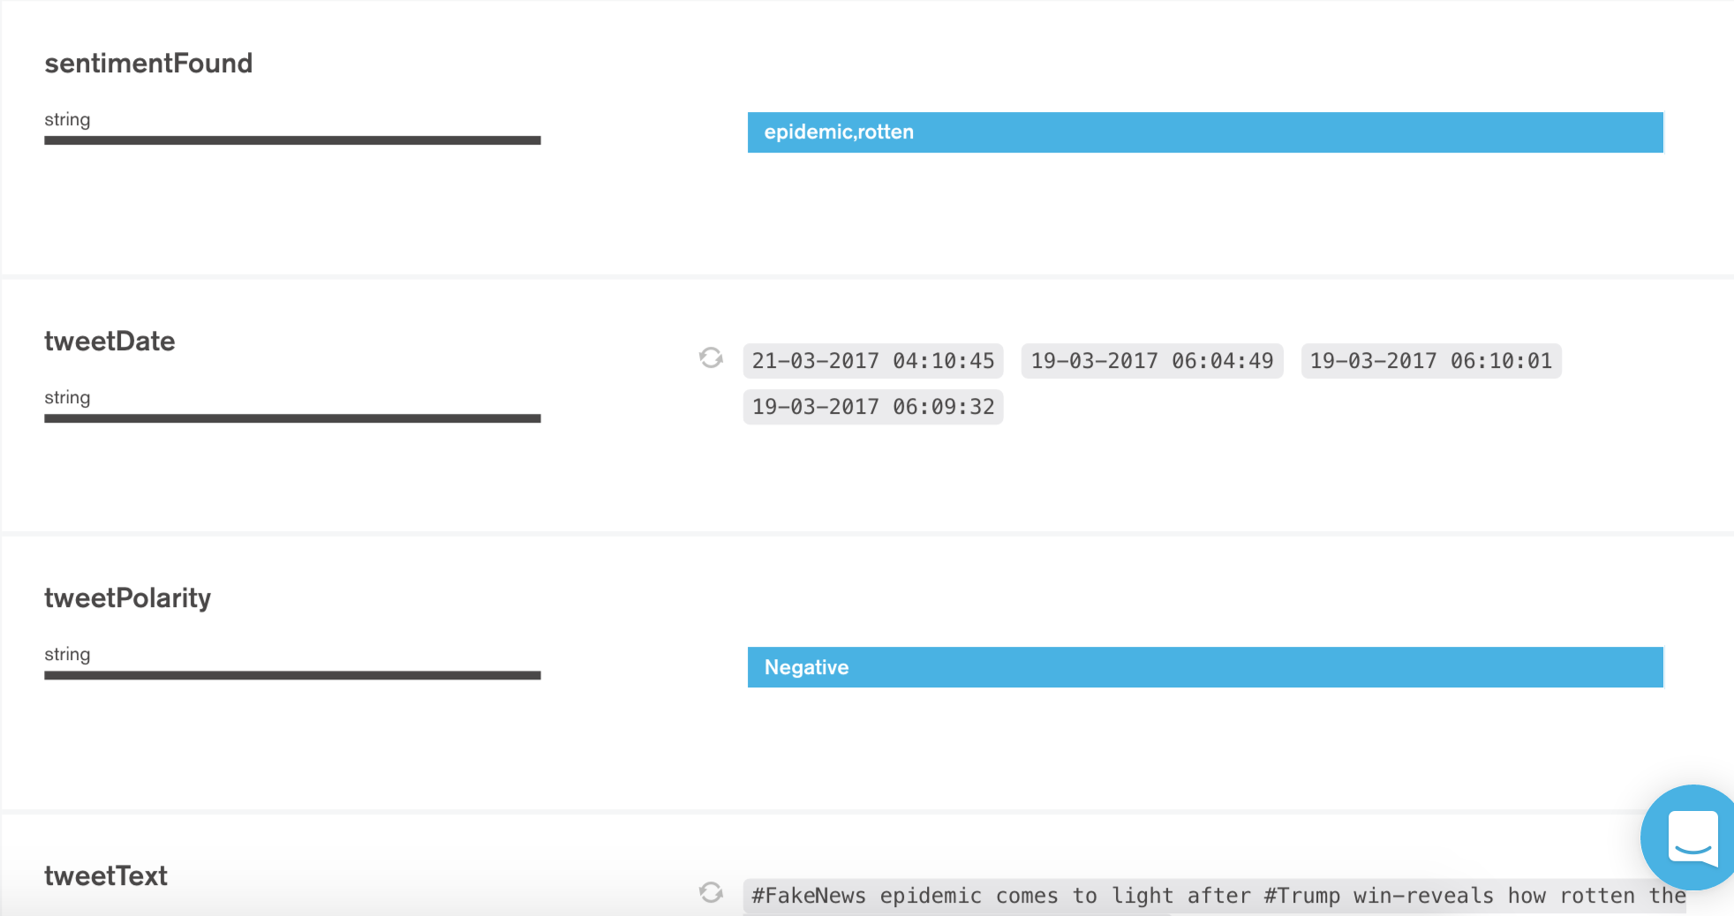An example of this can be seen below from the analytics tool Compass.

**User Interface**

* A user interface has now been created. This allows the user to interact with the application without seeing the code or inputting values into the console.
* Messages are displayed on based on criteria entered. If a field is left blank an error message is displayed.
* The basic UI can be seen below:

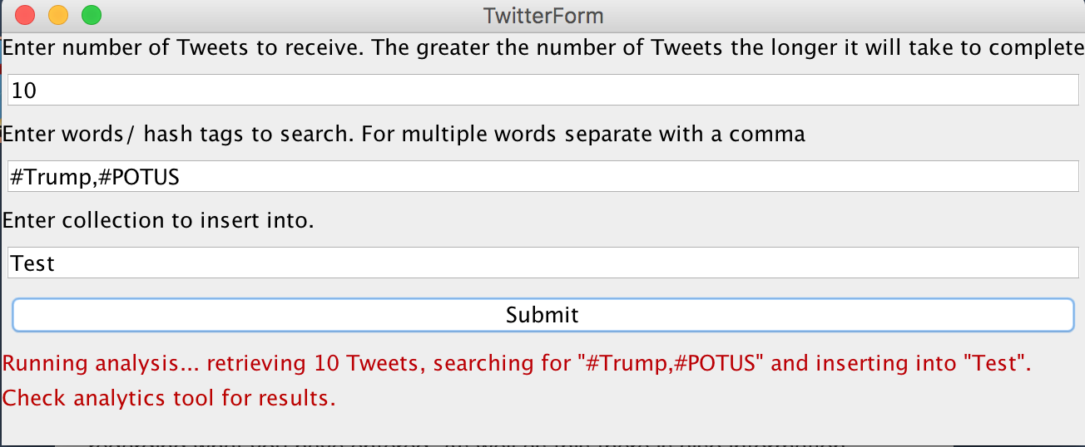

**Report**

* Updated abstract
* Wrote first draft of introduction.

### **Highlight 8**

**Programming**

* Structure
  + Renamed the main classes to represent the functionality better.
  + Renamed the directory containing the code that will become the final product so it is clear this is the case.
  + Split out the functionality that analyses the tweets for sentiment present and the insert into the MongoDb collection. This was to allow for additional functionality (such as the search) to be added easier without duplicating code.
* New functionality
  + Created the functionality for the search functionality. This will search past tweets for a few minutes before the current time (this can vary depending on the popularity of the search phrase and number of tweets matching this.)
    - This was implemented into the Java form for the application.
    - Code was added where needed in order to branch off into the search code when needed to be carried out (when tick box is ticked.).
* Java form
  + Added a tick box to allow the user to choose whether they would like the search to be carried out or not.
    - Code for the above was added to the Java form class to allow this functionality to be implemented.

**User interface**

* Tick box for the searching of past tweets was added.
* Text for the tick box was added.
* Warning was added to help prevent duplicates occurring, it is planned that this will be avoided elsewhere in the code so this will not be needed.
* The new UI can be seen below:

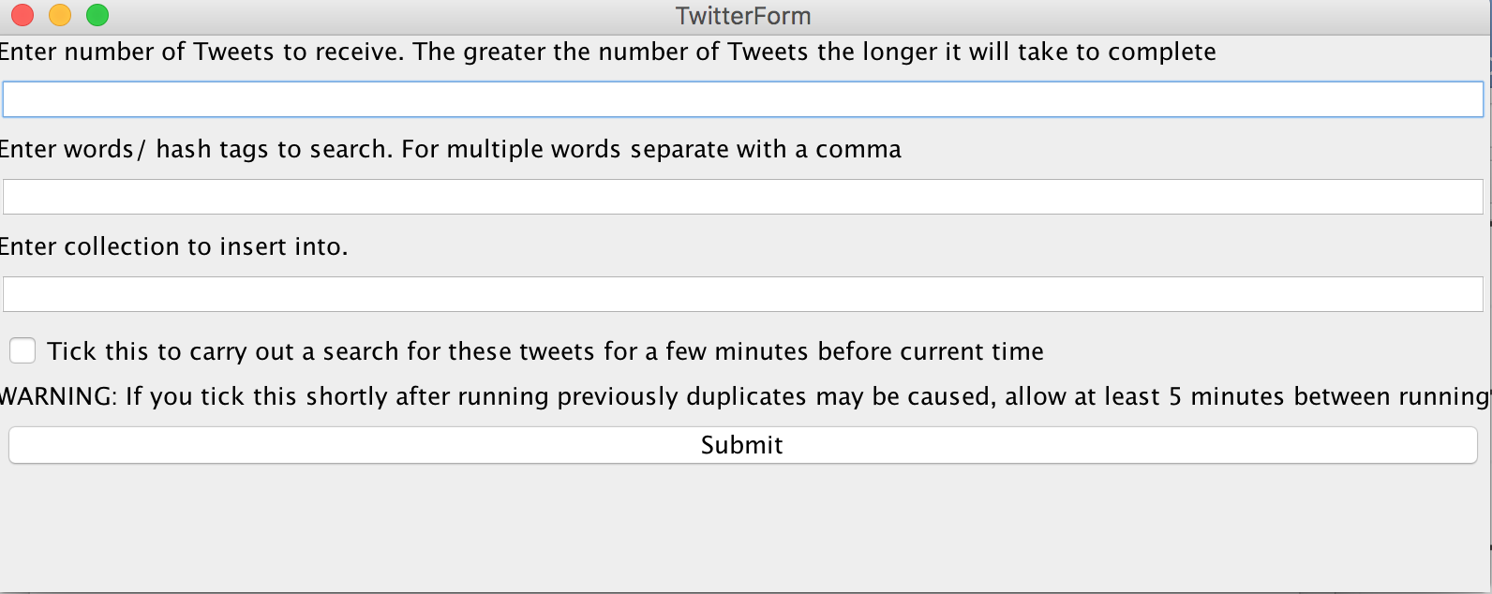

**Report**

* Improved introduction to be more precise and have more information as well as referenced sources and diagrams.
* Added background, objectives and deliverables section which contains some researching into the area of sentiment analysis on social media which may be split into its own section in the final version.
* Added project management section.
* Added overview of technologies used section which outlines the technologies used and a high-level overview of how they work, what they are and what they are used for in the industry.

**Data analysis**

* Cloud 9 Charts
  + Cloud 9 Charts has been decided to be used for the graphical analysis of the data retrieved and processed.
  + This software allows for easy connection to MongoDb Atlas and provides a lot of options when it comes to the graphical visualisation of the data.
  + It does require some basic SQL knowledge to perform more advanced functionality but can be used easy by anyone to create basic graphs.
  + 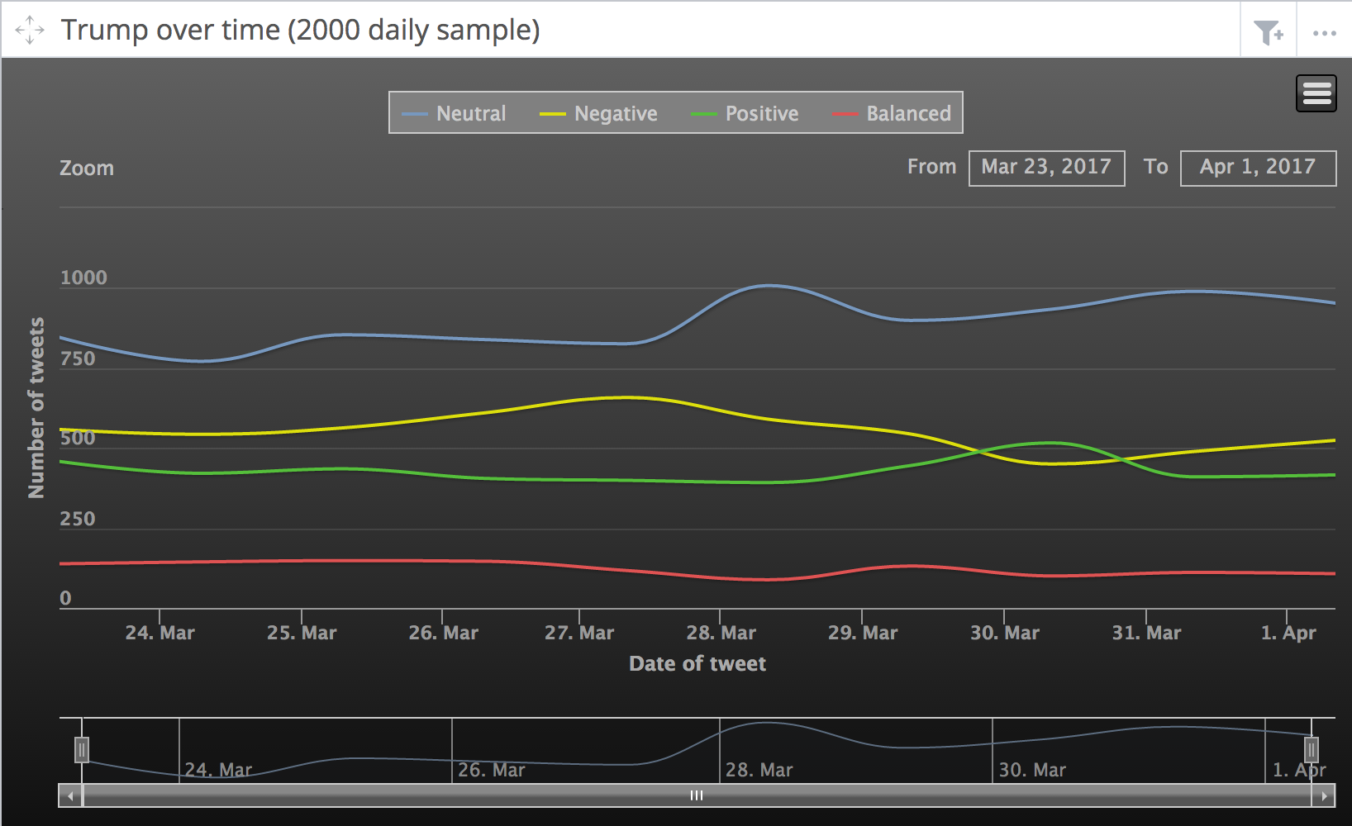Some examples currently implemented can be seen below:

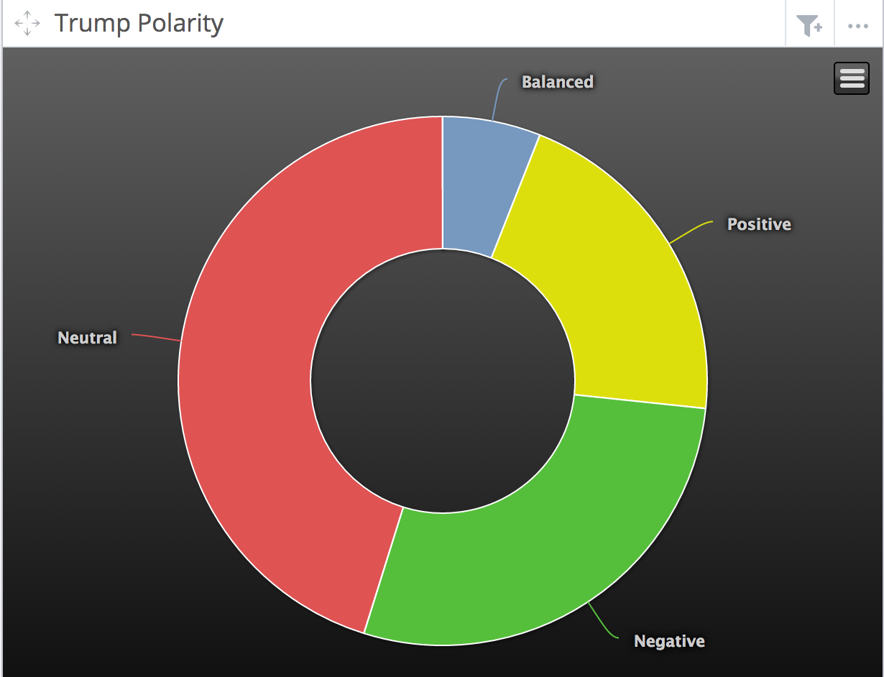

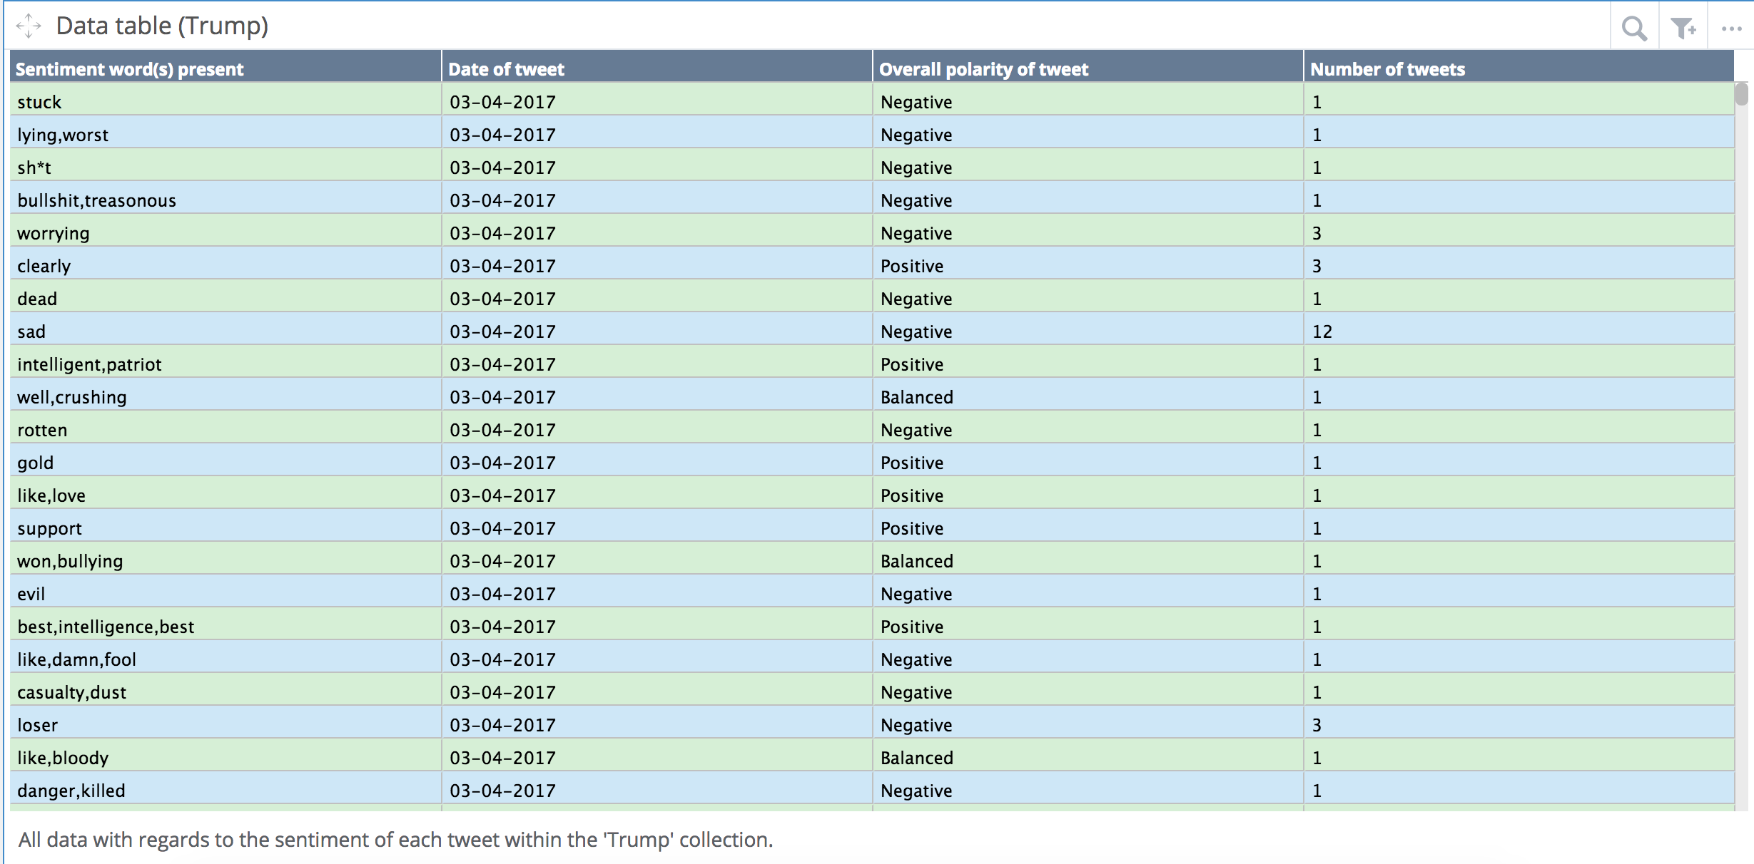

### **Highlight 9**

**Programming**

* Java form
  + Altered the tick box and form so when the box indicating if a search should be carried out is not ticked, the button to carry out only a search is greyed out, also when it is not ticked, the date field which indicates which date to carry out the search for is also greyed out.
  + Logic for a timer has been added in to allow for 15 minute windows that Twitter’s API allows. This is to prevent the rate limit being reached and the user being locked out.
  + Functionality for the collection select has been changed, now the previous text field is now a combo box (drop down list). All collections in the MongoDB Atlas database will be displayed for the user to select.
  + A button has been added and the functionality to refresh the collection list mentioned above. This allows the user to create a new collection and then refresh the list to see their new collection for the next iteration.
    - An image of both of the above two points can be seen below:

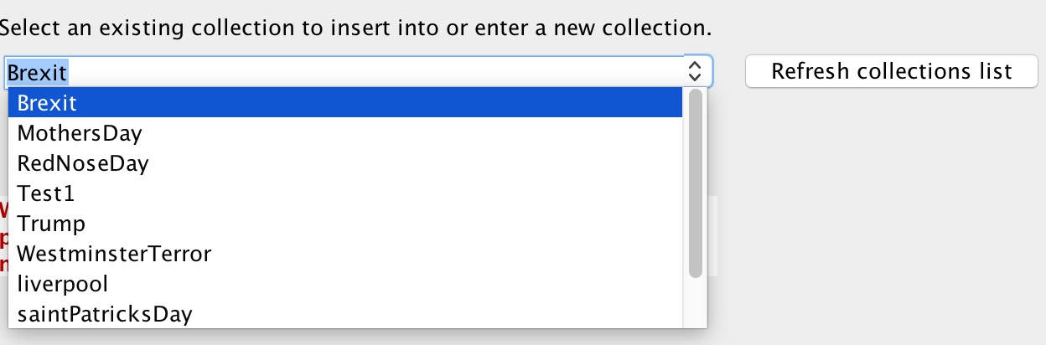

* New functionality
  + Additional code was implemented which works alongside the 15-minute timer. When a search is carried out, the timer will count down from 15 minutes and a record of the number of requests will also be displayed along with the timer on the form. The user is allowed a maximum of 170 requests per 15-minute window. Although Twitter API allows 180 requests per 15-minute window, it was decided on 170 to allow for addition requests if needs be without being locked out of the API.
  + When the timer hits 0 the number of requests will be reset.
  + If the user is at the limit the search will not run.
  + The stream and search button will execute the search and then the stream, this is to make sure the search does not overlap with the stream and retrieves duplicates.

**User interface**

* The tick box has been moved to the top of the form and has different text. The functionality has also been changed and can be read about in the ‘Java form’ point of the programming section.
* A box for the date to allow the user to select the date to search on has been added.
* A timer has been added to the top right corner.
* A request counter has been added to the top right corner under the timer.
* The button to refresh the collections list has been added.
* The warning has been changed to be more obvious.
* Previously the submit button was used for all executions, this has now been changed and split into two. This is to allow for the new search functionality.
  + Images of the UI can be seen below. They show what the form looks like when the search tick box is unticked and when it is ticked respectively.

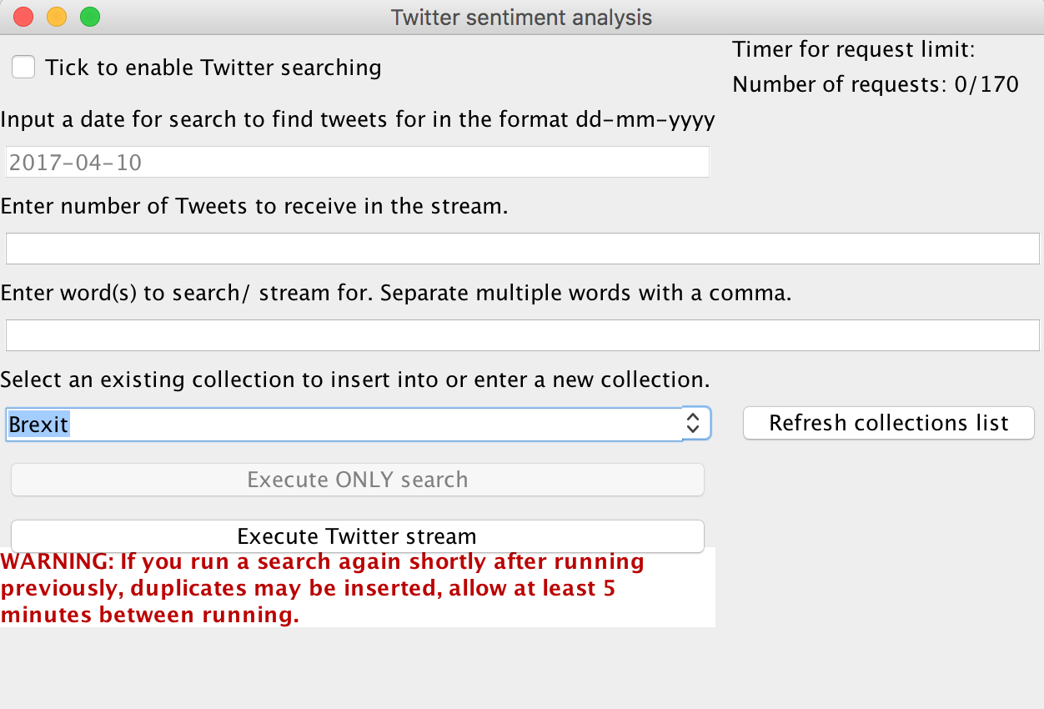

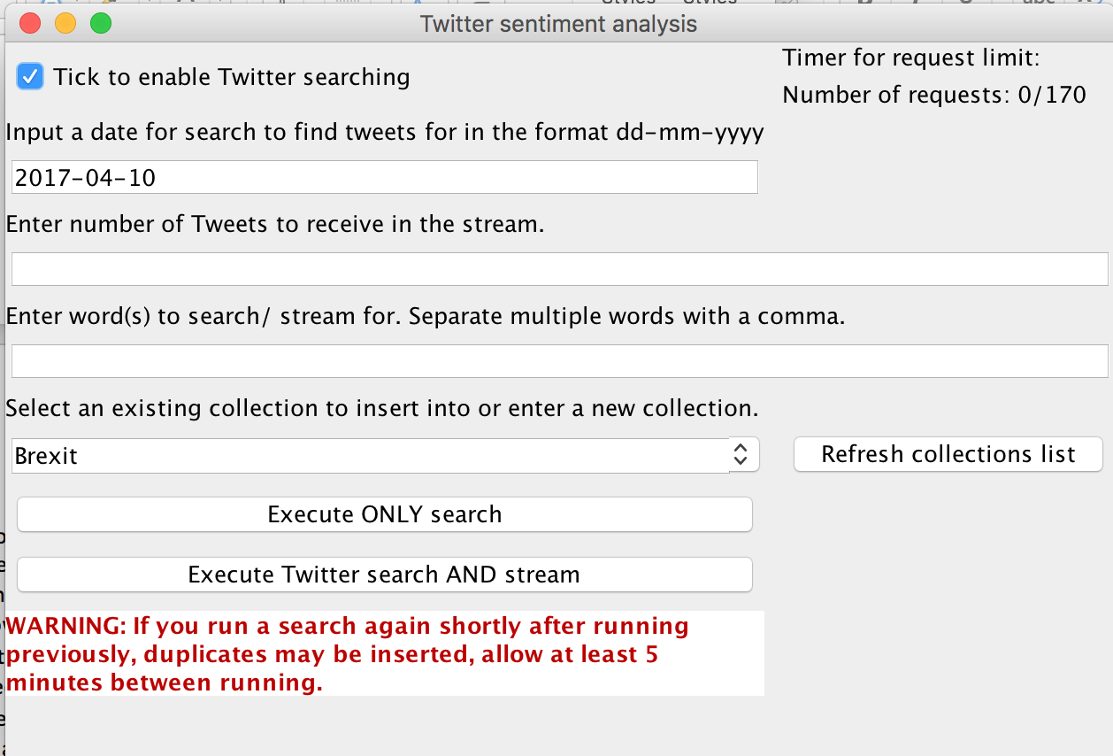

## **PID**

Introduction

Social networking and data analytics are a rapidly growing technology area. With billions of people on some sort of social network there is a wealth of data online. In the example of Twitter, an enormous volume of data is posted/ tweeted daily. All of this data in one place provides ample opportunity to extract useful information which can be leveraged to many areas of the technology industry to help develop and improve many businesses. Applying data analytics to the extracted data will allow the development of predictions, trending over time, popularity and many more. In the case of this project, sentiment analysis can be carried out to trend users feeling of certain topic areas allowing the operator to gauge the public’s interest and outlook on certain topic areas.

Business Case

Business Need

By using data from social networks businesses can benefit from information that is already available. Trending the publics feelings towards specific topic areas can be used in areas such as marketing, customer relations, advertising and more. This would add a layer to the business allowing them to access/ reach a larger audience where they before may not have been able to. Automating this process of retrieving data from Twitter, by using a Twitter API, will save time and money. Using hashtags to search for specific tweet will reduce the number of unrelated tweets retrieved for analysis.

Business Objectives

To increase a company’s productivity and to create/ grow the company’s data analytic capabilities by:

* Automating the Tweet retrieval process where the hashtag is the only thing changed.
* Storing all raw data in a series of tables in a sorted database.
* Populating the tables automatically when data has been retrieved.
* Using information gained from the analysis process to further develop the company and put the information to good use.

Project objectives

This project aims to provide a conclusive result formulated from the analysis of Twitter users based on the emotions portrayed in the Twitter content obtained. The objectives to aim towards are as such:

* To be able to extract tweets from Twitter based on text/ hashtag(s).
* To store the retrieved information in a useable fashion in a database system.
* Analysing tweets across time.
* Using sentiment analysis to determine the user’s emotion portrayed in the tweet.
* Graphically plot emotional change over time of tweets.
* Show how opinions of topic areas change over time.
* Determine the overall emotion felt towards topic areas.
* Allowing the extraction of useful information for all that stated above.

Initial Scope

This project is based on social network analytics. Mainly this will focus on sentiment analytics, trends and other interesting analytical outcomes of Tweets by Twitter users. The social network being used is Twitter, Tweets will be retrieved from Twitter using an API call. This API will be made using Twitter4J which is Java based code used to make calls to Twitter in order to retrieve the tweets based on some set criteria. The tweets to be retrieved will be based on specific hashtags and/or text present in the tweet. This data will then be stored in a database and used as the basis of the analytics to be carried out. There are three main components to this project these are as follows;

1. Java code using Twitter4J to carry out API calls to Twitter.
2. Database storage and management to store retrieved tweets and a collection of search phrases and sentiment phrases.
3. Data analytics and the production of graphical representation of the outcomes of the analytics.

Resources and Dependencies

* External hard drive storage if the data volume proves too much for local storage.
* Database storage if the storage for both an external hard drive and locally proves too much, or if it has been determined that using a database facility is needed.
* Access to tools such as Rapid Miner ( https://rapidminer.com/ ) and Tweet Stats (http://www.tweetstats.com/ ).

Method of Approach

Twitter4J is a Java based API program. It will be used, developed and written to meet the needs of this project and to carry out the main task of retrieving the data needed. The API results will be processed, formatted, split and copied to a table in a database which will be explained in more detail below.

The database will consist of a minimum of 3 normalised tables (although this is likely to be more in order to store additional information relating to the data); there will be a table which will contain all the search text needed to filter down which tweets to retrieve (these may be hashtags, keywords or phrases). This data could be anything from a topical current affair in the news or a trend that is currently occurring on Twitter/ the internet. Another table will contain all the sentiment phrases that will be used to determine the nature of each tweet, for example this table may contain words such as hate, love, like, dislike, terrible, horrible, brilliant, great etc. along with whether these words are negative, positive or neutral. The final core table will be used to store the tweets that have been retrieved by the API call and this table will be updated each time the API call is used.

The database will be stored locally on the host computer (the computer that is carrying out the API calls and analytics) and in the event that the database gets too big some data will be compressed and archived. If it is found that the database is still unmanageable the database/ data will be stored on an external hard drive with manageable chunks being accessed/ downloaded to the host computer at any one time.

The database, API and Java code will be used together as follows; the table of search text will be looped through with each record in the table altering the API call code to change which tweets will be returned. If this proves to be too intensive or time consuming the work load will be split across multiple threads and the GPU of the computer being used to increase performance with each thread taking one record from the table. The results returned by the API call will be processed by Java code and then written to the respective database table using SQL which will be embedded within a Java class allowing for ease of access and method calling.

The sentiment table will then be looped through, in the same fashion as the retrieval of tweets above, and compared to the results table where the data retrieved by the API will be stored. Each tweet/ record will then be assigned an overwhelming positive, negative or neutral feeling. These will be determined by the word(s) which the data contains in correspondence with the sentiment dictionary table.

This new dataset will then be used to carry out analytics. The analytics may include, but is not limited to, determining the sentiment of each text phrases and how this changed over time, showing the number of tweets over time containing certain text phrases, showing the most used/ unused emotional word in tweets from those present in the table and how these have changed over time, the number of emotional words used in tweets and the trend of this number relating to the overall sentiment of the tweet. All of the analysis, where appropriate, will be represented in both figures and a graphical representation. In order to do this, tools such as TweetStats and Rapid Miner may be used. TweetStats can produce histograms displaying information such as number of retweets (and most common retweeting users), number of replies (and most common replying users), tweet density and interfaces used (Instagram, Twitter for iPhone etc.). The data science tool Rapid Miner can be used for providing graphical outputs of the analysed data.

This project will be carried out under an agile workflow with a series of sprints being planned out in advance and progress evaluated a minimum of twice a week. The results of this will cause planned work to be adjusted as necessary for upcoming sprints. All work will be version controlled and stored on GitHub within a repository under a secure SSH key and all sensitive information (such as twitter login information) to be sure to be omitted in the git ignore file. The Git structure will consist of a Master branch, a feature branch and a test branch. Work will be done on feature branches and tested on the test branch. The test branch will contain the current contents of the Master branch. Once testing has passed this test branch will merged to the Master branch and the feature branch will be deleted. This is to maintain the integrity of the work and to allow back outs and code reverts to be easy while also keeping track of progress of work done.

The findings of the analytics will be briefly written up into documentation with some explanation to what was done and background information.

A stretch goal will be to implement a predictive model to predict outcomes of certain events, such political votes, based on the Twitter users feeling toward each party/ candidate. If this is completed an even further goal is to use the Facebook API on Facebook statuses and carry out the same process as Twitter and compare the results.

Project Plan

|  |  |  |  |
| --- | --- | --- | --- |
| **Project Plan** | | | |
| **Stage** | **Expected start date** | **Expected completion date** | **Products/ Deliverables/ Outcomes.** |
| 1. Initial idea proposal |  | December 9th | Initial write up and meeting on idea |
| 1. PID | January 30th | February 5th | PID |
| 1. Investigation and requirements | February 6th | February 15th | To investigate possible data storages and access e.g. SQLite, Oracle, MySQL etc. and Twitter retrieval APIs (How to use, which to use e.g. Twitter4J) analysis to be carried out and tools to use for this. |
| 1. High level design | February 16th | February 26th | Structure of the system i.e. the API links in to Twitter, Tweets retrieved to database and analyse carried out. |
| 1. Twitter data retrieval | February 27th | March 12th | To have a Twitter API set up and to be able to retrieve the data from Twitter. To be able to pass parameters to search Twitter for and the results retrieved are reliable. |
| 1. Set up database system and integrate into project. | March 13th | March 20th | To initialize the database and tables and to populate the sentiment table. |
| 1. Carry out sentiment analysis. | March 21st | March 31st | To search through populated tables and recognize the sentiment words. Use this to plot graphs. |
| **Easter Break** | **April 3rd** | **April 21st** |  |
| 1. Assemble and complete final report | April 24th | May 5th | Final PRCO304 Report |

Control plan

The following PRINCE2 control techniques will be employed:

1. Highlight reports as dictated by the PRCO304 module

2. Review meetings with project supervisor as dictated by the PRCO304 module (weekly); additional ad-hoc meetings as are necessary

3. Risk management; communication plan; quality plan; exception reports and plans as necessary.

4. Additional meeting with supervisor as needed

5. Record of work carried out kept.

Communication Plan

Review meetings will be held with the supervisor in line with the Control plan. Further ad-hoc communications will take place as needed either via email, SPMS or in the form of additional face-to-face meetings.

Initial risk list

|  |  |
| --- | --- |
| **Initial risk list** | |
| **Risk** | **Management strategy** |
| Schedule overrun. | Contingency has been introduced into the project plan. Highlight reports and review meetings will provide a regular monitoring of schedule. An exception plan will be developed, and approved by the project supervisor, in the event of more than 1 week’s slippage. |
| Difficulty learning/using the development technologies. | A very simple system prototype will be developed during Stage 2 (Investigation and requirements). Alternative technologies can be discussed if needs be with supervisor and other members of staff. |
| Loss of code/work/ data. | All code, work and data (if locally stored) will be version controlled on Git Hub. Commits and pushes will be made very regularly as work is carried out. |
| Lack of data retrieved. | If there is not sufficient data, or an event to retrieve data for, alternative events and search phrases should be used. If the problem continues to occur the analysis of the data will be changed accordingly. |
| Insufficient storage capabilities. | If it is found that the data storage of the data sets is not sufficient then old data will be deleted. Search phrases may also be altered and made more specific to reduce the number of results returned. |
| Insufficient time to complete work stated. | A MVP (minimal viable product) will be agreed upon ahead of time with the supervisor and this will be the new goal to be met. |

Initial quality plan

|  |  |
| --- | --- |
| **Initial quality plan** | |
| **Quality check** | **Strategy** |
| Requirements | Requirements will be checked to ensure that they are correct, relevant (i.e., traceable to the business objectives), complete, achievable and demonstrable. The requirements will also document required product quality criteria (e.g., usability). Prototyping, testing and discussions will be held to ensure requirements are met. |
| Design validation | The design will be checked against requirements compliance, DB normalisation and software design principles (e.g., cohesion, coupling). |
| Sub-system validation and verification | This will be conducted at the end of each stage. |
| Project/ code testing | Tests will be carried out as the project is developed to ensure each stage is fully complete before moving on. |
| System validation and verification | To be carried out when the project has been completed to ensure the full system is working together as expected with the correct outcome being produced. |

Legal, ethical, social and/or professional issues

(Project complies with the universities approved ethics application)

## **Appendix A (architecture diagrams)**

A1. Second iteration of the architecture of this project.

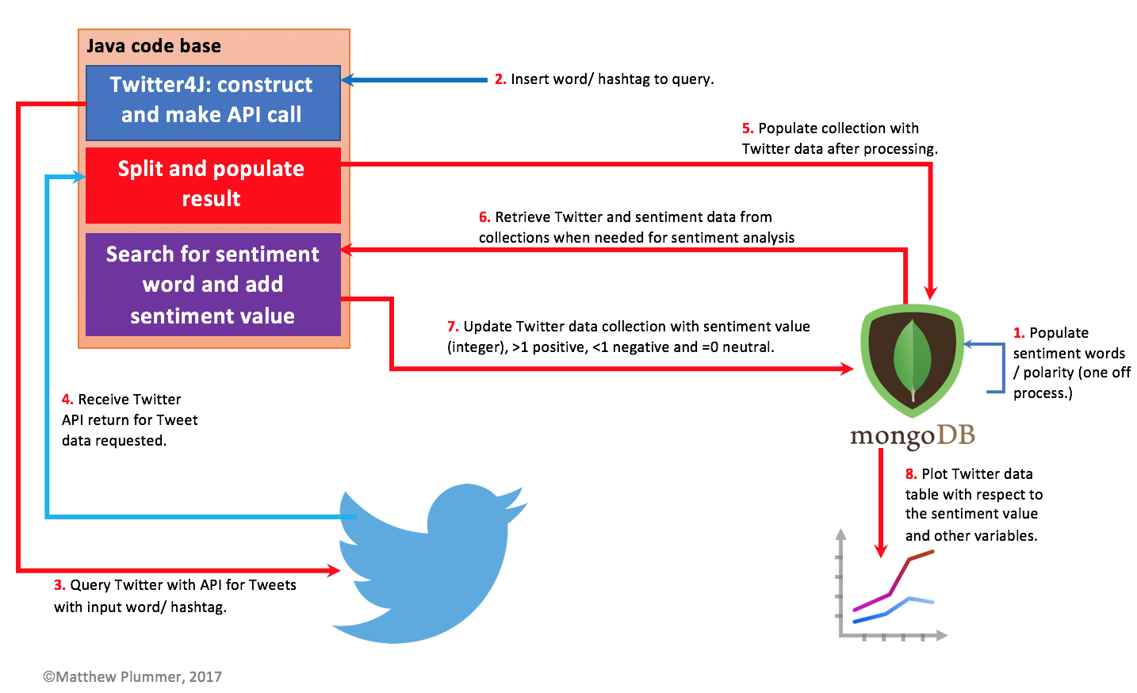

A2. Third iteration of the architecture of this project.

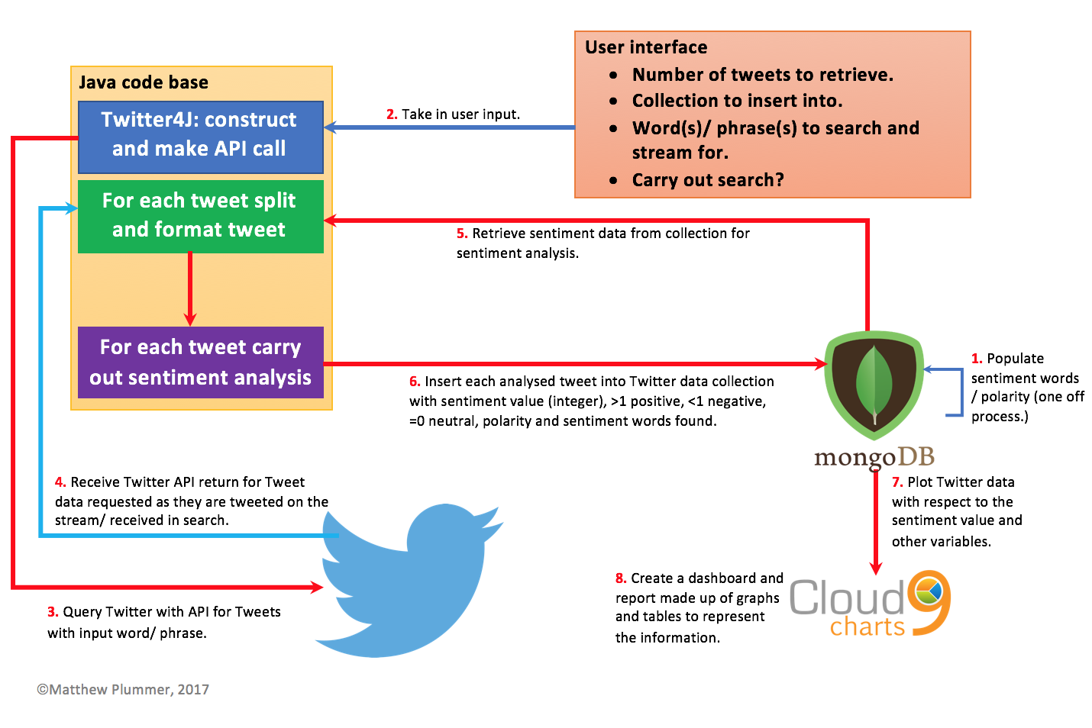

## **Appendix B (User interface)**

B1. The user interface where the user inputs their parameters for the application to run when the search is disabled. This U.I is seen upon running the application.

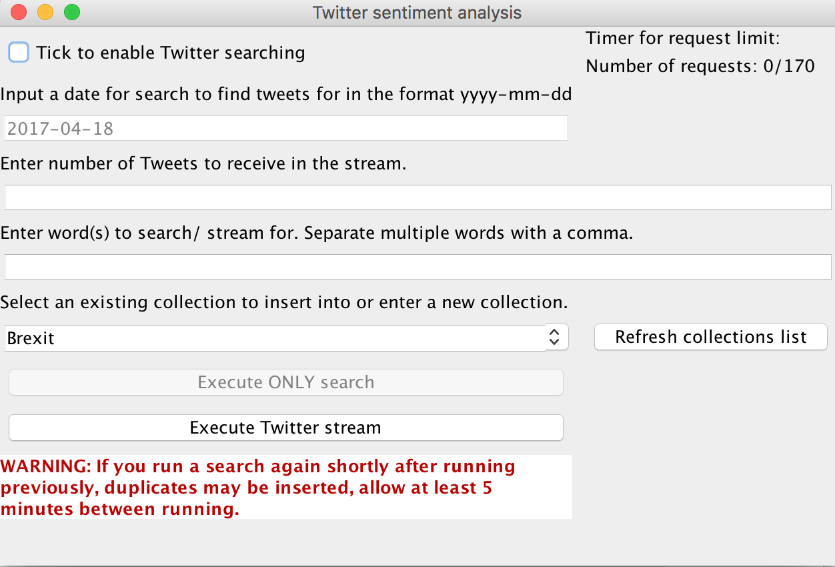

B2. The user interface where the user inputs their parameters for the application to run when the search is enabled. This U.I is seen upon running the application.

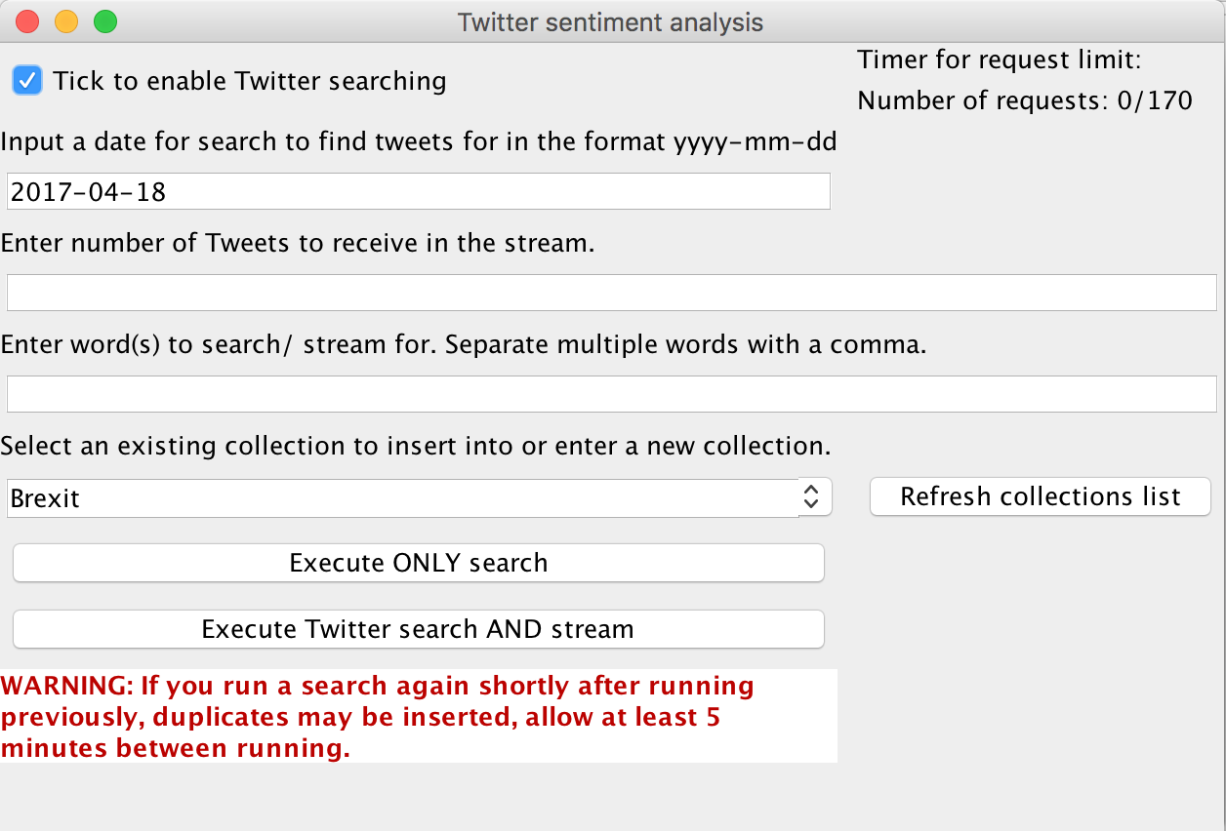

B3. The drop-down menu (combo box) displaying all the available collections within the database and cluster. There is also a button to the right which allows the user to check for new collection that have been newly created.

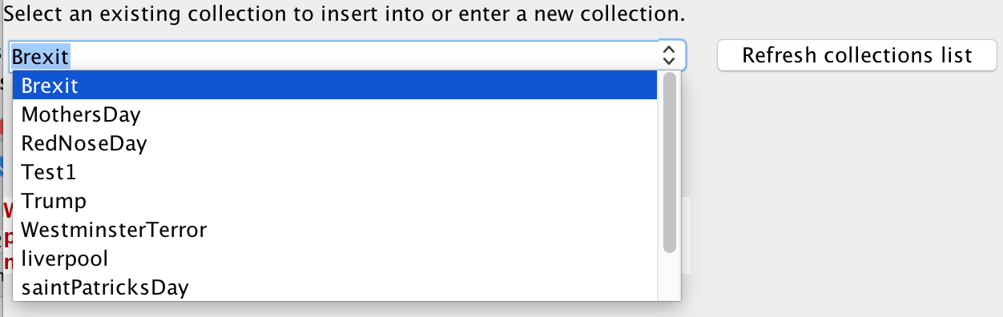

## **Appendix C (MongoDB Compass)**

C1. MongoDB Compass showing the breakdown of positive, negative and neutral sentiment using example hash tag #RedNoseDay which was executed on 24th March 2017.

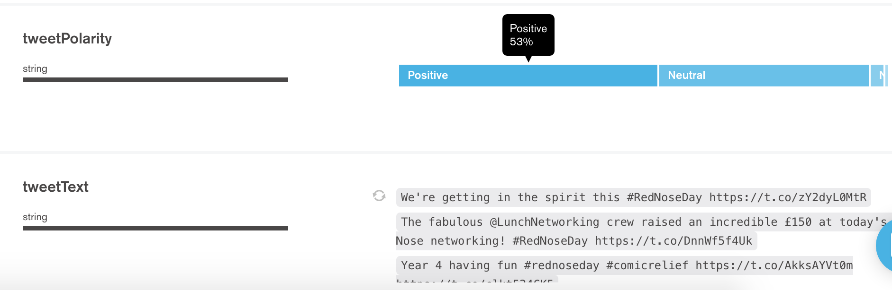

C2. MongoDB Compass showing the breakdown of overall sentiment value. The 0 value is highlighted with negative overall sentiments to the left and positive to the right.

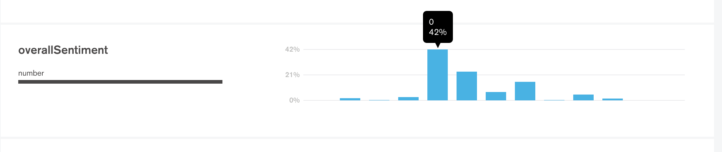

## **Appendix D (Knowi)**

### **D1. Trump data**

Knowi line graph showing the sentiment polarity of tweets over time for the search word #Trump on a daily 2,000 tweet sample.

D1a. Knowi showing a donut chart of a breakdown of the number of tweets for each polarity using search word #Trump and a daily 2,000 tweet sample.



D1b. Knowi word chart showing the sentiment words found present in tweets using the word #Trump over a daily 2,000 tweet sample. The larger the word the more common its usage.



D1c. Knowi table showing a breakdown of sentiment words present, date of tweet, polarity of tweet and number of tweets using the word #Trump on a daily 2,000 tweet sample.

## **Appendix E (Code snippets)**

### **E1. Filtering requests**

Code snippets for the code in which the request is built can be seen below for both search and stream respectively in figure 11 and 12.

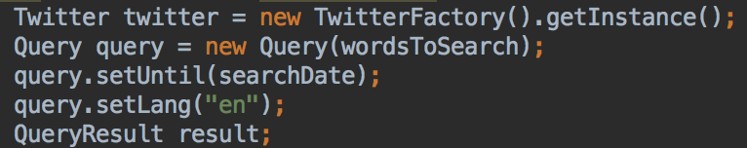

*figure 11: request filtering code for search functionality.*

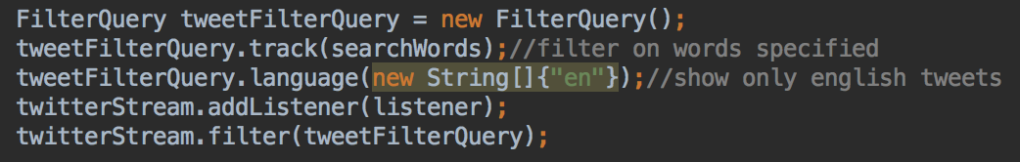

*figure 12: request filtering code for stream functionality.*

As can be seen from the code snippets above, both techniques will filter the requests to only retrieve those tweets that are in English and correspond to the search word(s)/ phrases/ hashtag(s) inputted by the user with both approaches use ‘query filtering’ to alter the information retrieved. Although this application will return only English tweets, other languages can be specified with their two letter ISO representations, for example German is ‘de’, French is ‘fr’ and Spanish being ‘es’ to name just a few. Alternatively, if no language filter is applied, tweets of all languages will be retrieved given other filter criteria is matched such as the date and search word(s). The date to search on (searchDate) is uniquely present in the code of the search functionality, this is due to the fact that the stream is a live feed of tweets from Twitter whereas the search looks into past tweets, therefore the date can be specified for the search functionality.

### **E2. Making requests (stream)**

The code snippet seen in figure 13 shows the process of retrieving the tweets specified by the user.

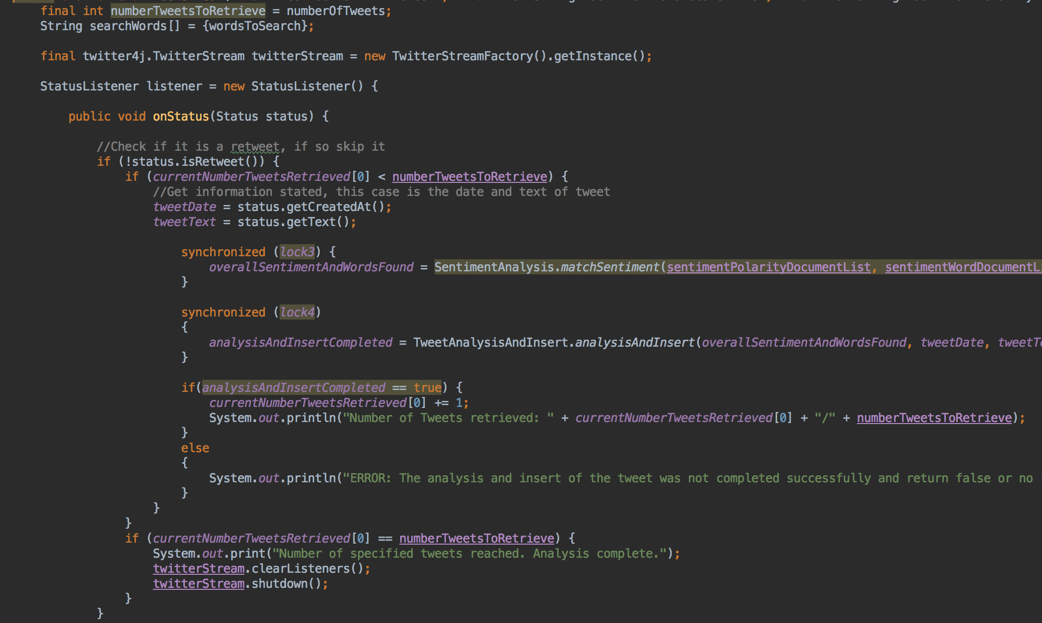

*figure 13: code for streaming tweets from Twitter via the Twitter API using Twitter4J.*

Twitter4J allows easy implementation of Twitters streaming service by simply creating a Twitter stream via the Java code. The code to create the Twitter streaming functionality can be seen in the line:

‘final twitter4j.TwitterStream twitterStream = new TwitterStreamFactory().getInstance();’

This variable ‘twitterStream’ is then used to call, and therefore use, the streaming functionality. Whenever a tweet is tweeted which matches the key search words entered by the user the ‘onStatus’ method will be called. The listener being removed and the Twitter stream being shutdown can be seen in figure 13 on these two lines:

‘twitterStream.clearListeners();’

‘twitterStream.shutdown();’

Twitter4J uses a series of ‘get’ methods to extract specific information from each tweet. As can be seen in figure 13, ‘status’ denotes the tweet and all information with regards to that tweet which was returned from the Twitter API listener. As can also be seen from the code snippet in figure 13 a series of synchronized loops and locks can be observed. These serve the purpose to ensure that the code will not continue until the method/ class called within these loops has sent a return. This is done due to the fact that if the code does not wait for the called code to complete, the software will exit with an error. In having these locks a fail-safe is in place to ensure that the mentioned error does not occur. This functionality can be seen throughout this projects code base as the execution of the code must happen in a specific order.

### E3. Making requests (search)



*figure 14: code for searching for tweets from Twitter via the Twitter API using Twitter4J.*

Similarly, to the Twitter4J stream code, Twitter4J also has reserved functionality for searching. This can be seen in the line:

‘result = twitter.search(query);’

More specifically the TwitterJ4J function of ‘search();’ which will do just that, it will conduct a search on Twitter using the specified filters from the parameter variable ‘query’. Once the tweets have been retrieved they are added to a list, again using the reserved functionality/ method ‘getTweets();’ which can be seen in figure 14 on the line:

‘List<Status> tweets = result.getTweets();’

This list is then used to iterate through in the while loop which follows it. Depending on the popularity of the search word(s)/ phrase the user inputs into the user interface the number of tweets retrieved via the search will vary. A more popular search word will retrieve more tweets over a shorter period of time, whereas a lesser used search word will return fewer tweets over a longer period of timer, both of which are only conducted on the search date the user specified upon executing the search.

## **Appendix F (Twitter’s API service status)**

### **F1: Twitter API service status for debugging**

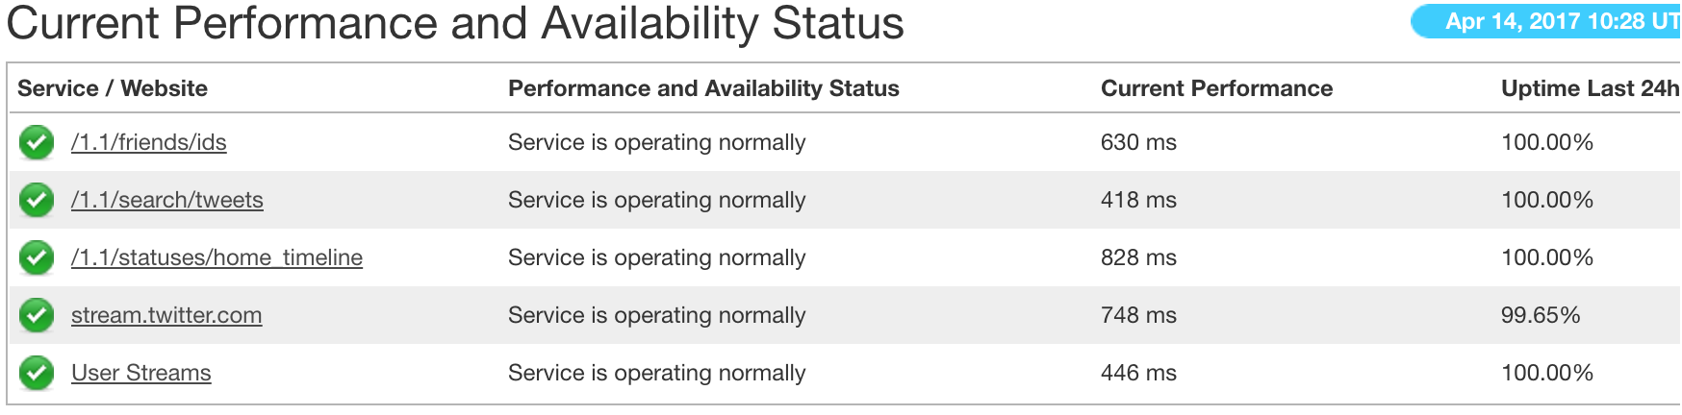

*figure 10: Twitter API service status table* (Twitter, 2017)

The status of Twitter’s API service can easily be seen via a website[14] for developers, an example of this status table can be seen in figure 10 which also shows all the different components of Twitters API service.

If issues with the connection to the Twitter API ever occurred in the code or when running the application, this is what was the first thing checked. This allowed the possibility of the API service being down to be eliminated meaning that the issue is within the code. Contrary if the service is down (which is very rare) this will save time and effort with regards to debugging code when there is no issue with it. In Twitter allowing the public to access their API service some form of authentication is required. To do this Twitter have a ‘key’ system which is enforced to authenticate the user, this system uses OAuth. Twitter developers explain this best by explaining that:

*“This (OAuth authentication) is the most common form of resource authentication on Twitter OAuth 1.0A implementation to date. Your signed request both identifies your application’s identity in addition to the identity accompanying granted permissions of the end-user you’re making API calls on behalf of, represented by the user’s access token.”*

(Twitter, 2017)

## **Appendix G (Data comparison)**

### **G1. 2017 U.K. General election project data versus Google Trends data.**

G1a. Showing the first major spike when the general election was first announced. The comparison of this projects results to the results of Google Trends can be seen below respectively.

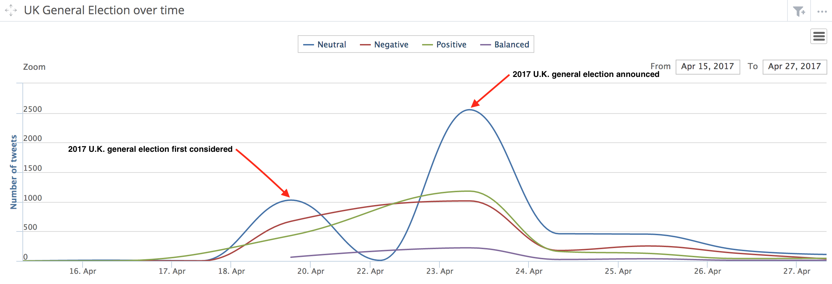

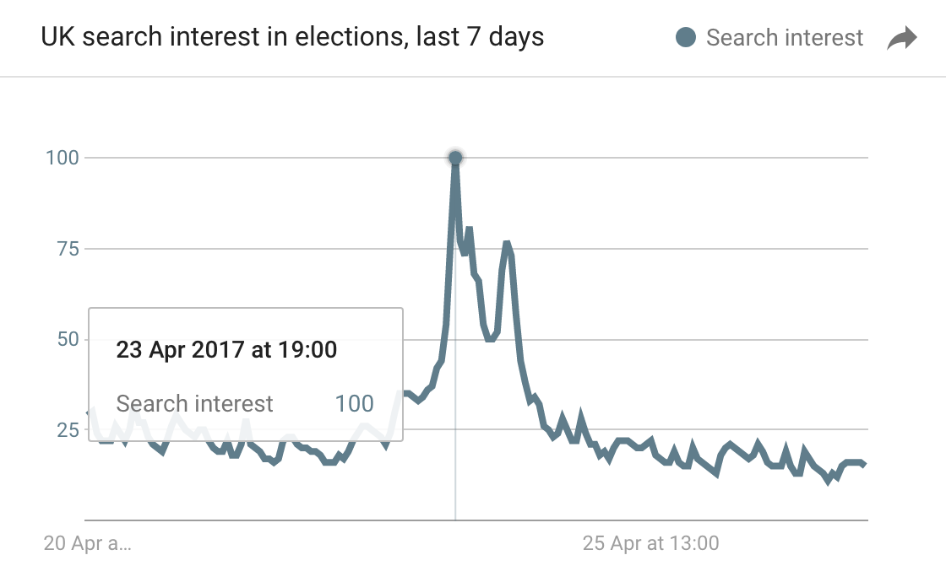

G2a. Showing the second major spike when the results of the local elections were released. The comparison of this projects results to the results of Google Trends can be seen below respectively.

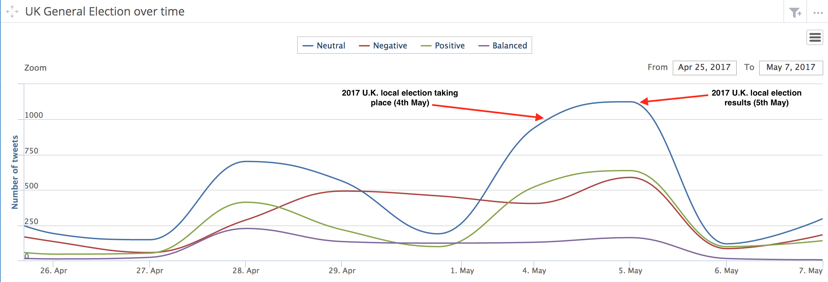

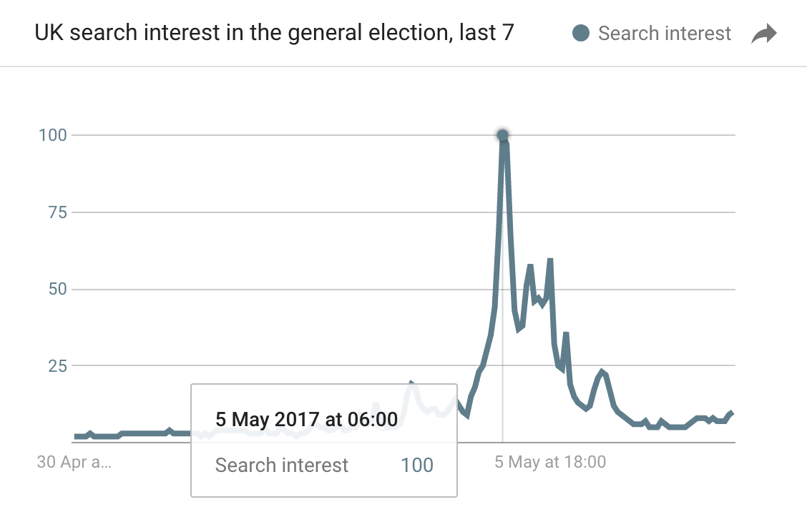

1. Download here: <https://www.jetbrains.com/idea/>
2. Access here: <https://www.mongodb.com/cloud/atlas>
3. Download here: <https://www.mongodb.com/products/compass>
4. Access here: <https://github.com/>
5. Twitters terms of service and privacy policy: <https://twitter.com/tos>
6. Download here: <http://twitter4j.org/en/index.html>
7. Access here: [www.knowi.com](http://www.knowi.com)
8. Google trends can be found here: <https://trends.google.co.uk/trends/>
9. Positive words located here: <http://ptrckprry.com/course/ssd/data/positive-words.txt>
10. Negative words located here: <http://ptrckprry.com/course/ssd/data/negative-words.txt>
11. Twitter application service: <https://apps.twitter.com/>
12. Maven and Gradle code: <https://mongodb.github.io/mongo-java-driver/>
13. Documentation for Java driver: <https://docs.mongodb.com/ecosystem/drivers/java/>
14. Developer website for Twitter API status: <https://dev.twitter.com/overview/status>